The WACC for Regulated Telecoms Services in Georgia

Prepared By  Dan Harris  Lucrezio Figurelli  19 January 2026 | Prepared For  Georgian National Communications Commission (ComCom)



Notice
This report was prepared for Communications Commission, in accordance with The Brattle Group’s engagement terms, and is intended to be read and used as a whole and not in parts.

The report reflects the analyses and opinions of the authors and does not necessarily reflect those of The Brattle Group’s clients or other consultants.

There are no third-party beneficiaries with respect to this report, and The Brattle Group does not accept any liability to any third party in respect of the contents of this report or any actions taken or decisions made as a consequence of the information set forth herein.

© 2026 The Brattle Group

Table of Contents
I. Introduction 1
II. Summary 3
II.A. Cost of equity 3
II.A.1. Risk-free rate 3
II.A.2. Equity Risk Premium (ERP) 4
II.A.3. Selection of the peer group 5
II.A.4. Beta and gearing 6
II.B. Cost of debt 7
II.C. Relevance of an NGA premium 9
II.D. Application of a different WACC for mobile and fixed Telecommunications operators 12
II.E. WACC of the Telecommunications Sector in Georgia 12
III. The Risk-Free Rate 14
III.A. Reference Country 14
III.B. Averaging Period 15
III.C. Maturity of the Bond 17
III.D. Calculation of the Risk-Free Rate for telecoms services in Georgia 20
IV. The Equity Risk Premium 23
IV.A. Methodological Considerations 23
IV.A.1. Methodology for Estimating the ERP 23
IV.A.2. Geographic scope of the ERP 24
IV.B. Evidence on the ERP 25
V. Selection of the Peer Groups and Screening Tests 29
V.A. Potential Peers 29
V.B. Liquidity and other screening tests 31
V.C. The Final Sample of Peers 33
VI. Beta and Gearing 34
VI.A. Methodological considerations 34
VI.B. Peer Groups Equity Betas 35
VI.C. Peer Groups Gearing and Asset Betas 38
VI.D. Gearing and Asset Beta for the Telecommunications Sector in Georgia 39
VI.E. The impact of country size on Telecommunications operators’ systematic risk 40
VII. Cost of Debt 44
VII.A. Alternative measures of the cost of debt for Georgian Telecoms Operators 44
VII.B. Conclusions on the Cost of Debt 49
VIII. Relevance of an NGA premium in the Telecoms sector in Georgia 53
VIII.A. Review of regulatory precedent and evidence on the fiber premium 53
VIII.B. Recommendation on the relevance of a WACC premium for investments in next-generation networks in Georgia 60
IX. Application of a different WACC for mobile and fixed Telecommunications operators 64
X. WACC 65

Table of tables
Table 1: WACC for Telecommunications sector in Georgia 13
Table 2: Average Spread between 20- and 10-year bond yields 19
Table 3: Risk-Free Rate for regulated activities in Georgia 22
Table 4: Historic Equity Risk Premium Relative to Bonds (1900 – 2024) 26
Table 5: World and Europe Equity Risk Premium (2021-2025) 28
Table 6: Potential Peer Group 31
Table 7: Screening Tests Summary 33
Table 8: Equity betas 37
Table 9: Equity betas and asset betas 39
Table 10: Asset beta and gearing for telecommunications in Georgia 40
Table 11: Regression results of populations and country size on asset beta 42
Table 12: Regression results of Market Capitalization on asset beta 43
Table 13: Cost of debt – PwC’s approach 45
Table 14: Cost of debt – embedded cost of debt approach 47
Table 15: Cost of debt - BEREC 49
Table 16: Cost of debt for telecommunications operators in Georgia 51
Table 17: Median asset betas of incumbent and alternative operators 59
Table 18: WACC for the telecommunications sector in Georgia 65

Table of figures
Figure 1: The empirical security market line 17
Figure 2: Differences between Euro AAA and Georgian Bond Term Premiums for 5-year and 10-year bonds 20
Figure 3: Yield on 10-Year Georgian Government Bonds 22
Figure 4: Bid-ask spread, 5-year weekly average 32
Figure 5: Rolling betas, 5Y weekly vs 2Y daily 36
Figure 6: Current Fiber Premiums Selected by European Telecoms Regulators 57
Figure 7: Initial Fiber premiums selected by European Telecoms Regulators 58
Figure 8: Fiber Penetration of Georgian Internet Market 61

Introduction

- The Georgian National Communications Commission (“ComCom”) is responsible for regulating telecoms services in Georgia. In line with its regulatory objectives, ComCom periodically reviews the methodology for determining the allowed rate of return for regulated services. The Weighted Average Cost of Capital (“WACC”) plays a central role in this process, as it defines the fair return that operators are entitled to earn on their investments.
- ComCom has commissioned The Brattle Group (“Brattle”) to conduct a comprehensive review of its current WACC methodology for telecoms services in Georgia and to develop a methodology for the calculation of the WACC for the next regulatory period starting in 2026. In doing so, ComCom has asked us to account for:
  - ComCom’s current methodology, as set out in ComCom’s decision of June 2022 and in the 2020 PwC Report;
  - The recommendations of the European Commission’s guidelines;
  - The annual reports published by the Body of European Regulators for Electronic Communications (“BEREC”); and
  - Any country-specific risks relevant to estimating the WACC of telecoms operators in Georgia, including any potential currency effects and the relatively small size of the Georgian market.
- ComCom has further asked us to assess (1) whether the WACC should be differentiated or not for mobile and fixed telecoms services, (2) whether a premium on the WACC should be applied for investments in next-generation networks, including fiber and 5G, and if so how large, and (3) any other issue relevant to the calculation of the WACC for telecoms services in Georgia that may emerge during the project.
- In preparing this report, we use data up to and including 30 September 2025 (measurement date), being the most recent data available at the time of our analysis.
- In this report we estimate the cost of equity by applying the Capital Asset Pricing Model (CAPM). Using the CAPM makes sense for ComCom as it is the method that all EU regulators apply and recommended in the EC Guidelines. Hence, we consider it appropriate to continue to apply the CAPM to calculate the cost of equity for telecoms operators in Georgia. Accordingly, in this report we do not discuss alternative methods of estimating the cost of equity, such as Fama-French models.
- We structure this report around the key elements of the CAPM and the cost of debt, being
  - The risk-free rate (section III).
  - The Equity Risk Premium (section IV).
  - The calculation of beta, including the selection of peer companies and the debt level or gearing we assume (sections V and VI).
  - Cost of debt (section VII).
- We further discuss In section VIII whether ComCom should continue to apply an NGA premium, and if so what should the premium be and in section IX whether ComCom should apply a different WACC to fixed and mobile services.
- We summarise our conclusions in the next section.

Summary

Cost of equity

Risk-free rate
- We recommend ComCom to calculate the risk-free rate taking the one-year average of 10-year government bonds in Georgia plus an adjustment of 60 basis points to reflect the spread between 20-year and 10-year government bonds.
- The use of Georgian government bonds as the risk-free rate is consistent with the recommendations of the EC Guidelines and more broadly with international regulatory practice. All regulators that we are aware of either use the bond yields of their country to calculate the risk-free rate or, exceptionally, use the risk-free rate of a very low risk (AAA rated) bond trading in the same currency, and then make an explicit adjustment for country risk based on the yields of their own bonds. The latter would not be a practical solution for Georgia as there are no other government bonds with a AAA rating trading in GEL.
- A second important aspect of the risk-free rate calculation is the averaging period. While the EC Guidelines recommend using a five-year-averaging period, there are at least two reasons why a five-year averaging is not appropriate for calculating the WACC of telecoms services in Georgia. First, there is no basis to think that the average of the risk-free rate of the last five years will be the best predictor of the risk-free rate for the next regulatory period. All things equal, the best predictor of the future risk-free rate is the current yield. Second, many European regulators have departed from the EC Guidelines because the use of a five-year averaging period generated unreasonable results. Therefore, consistent with the recommendations in the Brattle 2016 report for the European Commission (“Brattle 2016 Report”), we recommend using an averaging period of one-year.
- Finally, to ensure consistency with the ERP, ComCom should ideally calculate the risk-free rate based on 20-years bonds. However, this approach is not feasible in the present case, because there are currently no traded 20-year Georgian government bonds. As an alternative, we recommend ComCom use bonds with a maturity of 10 years and to apply an adjustment of 60 basis points to reflect the spread between 20-year and 10-year government bonds.
- Adding a 60 basis points adjustment to the one-year average yield of 9.10% results in a risk-free rate of 9.70%.

Equity Risk Premium (ERP)
- The equity risk premium (ERP) measures the additional return, or premium, needed to compensate investors for the risk of holding risky equities, or shares, as opposed to holding a risk-free asset. Importantly, and unlike the risk-free rate, the ERP is not observable.
- Regulators generally estimate the ERP using historical data, by looking at long-run averages of the excess returns of stocks over bonds across countries. The source of historical data that most EU regulators use is the annual publication by DMS which provides long-run estimates of the average realized ERPs from the 1900. The EC Guidelines also recommend estimating a European ERP based on historical data on the realized arithmetic average of the ERP for European countries. Alternative methods for estimating the ERP are dividend growth models (DGM), which reflect the implied premium resulting from current stock prices and assumed dividend growth rate, and survey data. DGMs, however, tend to be volatile and driven by assumptions, whereas survey data shows very large variability and is often driven by optimism or pessimism about the market outlook. Accordingly, we recommend ComCom to estimate the ERP for telecoms services in Georgia based on historical data, also consistent with the EC Guidelines.
- A second important Issue to consider when estimating the ERP is the geographic scope. In principle, there is no such thing as a ‘Georgian ERP’ or a US ERP. At the extreme, if investors where perfectly diversified over the world, it would make sense to try and measure a ‘worldwide’ ERP. In practise, however, economists have found evidence of ‘home bias’. That is, investors have a tendency to invest more in markets to which they are geographically closer, or they are familiar with, and often with which the investor shares a common language. At the same time, it would be too extreme to suppose that investors only concentrated on their own country, and did not make investments outside.
- The EC Guidelines recommend EU member states to consider a European ERP. However, while Georgia has applied for membership, Georgia is not yet part of the EU. Hence, a question remains as the relevant geographic scope of the ERP for Georgia. In principle, one could consider countries that are similar to Georgia and try to estimate a weighted average ERP for those countries. However, long-run historical data for such countries do not exist. This narrows down the calculation of the ERP to two options: considering a European ERP or a world ERP.
- Our analysis of the DMS data indicates that the market cap weighted average of the ERP for Europe (5.9% in 2025) is lower than the weighted average for all DMS countries (6.8% in 2025). On the other hand, composite indices published by DMS show a lower and similar value of the ERP for Europe and the world (4.6% in 2025). Effectively, this evidence suggests that the difference between the ERP for Europe and the world ERP, if any, should be small.
- We further note that there is no good theoretical reason why Georgia would have a higher ERP than average European countries. Also, the higher country risk of Georgia is already considered in the risk-free rate. Hence having a higher ‘Georgian’ ERP would risk double-counting such country risk.
- Based on the above consideration, we recommend ComCom to select BEREC’s estimate of the ERP for Europe from BEREC’s annual publication, as the methodology employed is transparent and provides an estimate that is reasonable and comes from an objective source. This approach results in a value of the ERP for telecoms services in Georgia equal to 5.9%.

Selection of the peer group
- The regulated Georgian companies in the telecommunications sector are not listed on a stock exchange. Therefore, to estimate the beta parameter, we need to find publicly traded firms with similar systematic risks. We refer to these companies as the ‘comparables’ or ‘peers’.
- In 2020, PwC considered a sample of 13 companies that own electric communication infrastructures, which included companies from Europe (10), China (1) and Russia (2). On the other hand, BEREC’s annual report regularly calculates betas considering only European peers. We create a ‘long list’ of peers by starting with the peer groups of companies considered in the PwC report and in the latest BEREC report, as well as the peer groups considered in prior Brattle reports for the telecoms sector, including three companies outside of Europe. From this group, we exclude the two Russian companies due to the lack of public trading and financial data.
- Because the regulatory framework under which a telecoms firm operates determines how the firm’s revenues and profits vary under different economic circumstances, it will be a key determinant of the firm’s systematic risk. For this reason, we should ideally select peers from countries with a broadly similar regulatory framework as the Georgian framework.
- We note that companies operating in EU countries share a similar regulatory framework with Georgia and should definitely be considered in the analysis. Also, the broad number of European peers already provides us with a large enough sample to obtain a robust beta estimate. On the other hand, we note that it is unclear whether the regulatory framework in China is similar to the regulatory framework in Georgia. Therefore, including betas of Chinese firms might not provide an accurate estimate of the beta for telecoms firms in Georgia. Accordingly, we recommend ComCom to estimate beta considering only the European peers.
- To obtain a reliable beta estimate, we apply several screening criteria to each of the candidate peers. Specifically, we exclude companies that are not sufficiently liquid, companies with a credit rating below investment grade and companies that were involved in substantial M&A activity. After application of these criteria we end up with a sample of 20 European companies.

Beta and gearing
- Consistent with the EC Guidelines, we estimate the equity betas for the peer group using a five-year estimation window and weekly data frequency. We estimate equity betas by returns of individual stocks on the returns on a reference market index. We select broad industrial indices as the reference market index for each peer. Specifically, we use the STOXX Europe Total Market Index for European companies and the FTSE All-Share for UK companies.
- Consistent with the recommendations of the EC Guidelines, we unlever the equity betas using of the Modigliani and Miller formula and a debt beta. We calculate the gearing of each peer taking the average of quarterly gearing ratios over the same time horizon used to estimate the beta. We calculate the quarterly gearing ratios by dividing quarterly net debt over quarterly market capitalization. As a measure of debt beta, we select a value of 0.1 for all peers. We note that, in principle, the debt beta of the peers varies with their risk of default. In practice, however, the rating of the peers fall within a narrow range – between BBB- and A- – and the EC Guidelines recommend using a single value of debt beta to reduce complexity and improve transparency.
- Overall, we calculate a median asset beta of 0.40 and a median gearing (D/E) of 71%. We recommend ComCom to apply these values in calculating the WACC for telecoms services in Georgia.
- Finally, ComCom has further asked us to consider whether the relatively small size of the Georgian market could potentially affect the systematic risk of telecoms operators. To evaluate this potential impact, we have analysed the relation between the estimated betas and demographic variables including land area, population and GDP per capita. Intuitively, a larger area could involve higher investments and risk, everything else equal. Conversely, a higher population might increase economies of density and reduce risk. Similarly, higher GDP per capita might imply a lower price sensitivity of consumers. Our analysis finds no evidence of a statistically significant relation between land area and population and a firm’s beta. Hence, we conclude that there is no impact of country size on the systematic risk of telecoms operators and, as a result, there is no need to adjust the asset beta to account for Georgia’s relatively small size.

Cost of debt
- In 2020, PwC calculated the cost of debt as the sum of a debt premium over the risk-free rate. The debt premium, in turn, was calculated by subtracting the risk-free rate from the one-year average interest rate on corporate loans in Georgia, as published by the National Bank of Georgia.
- In contrast, the EC Guidelines recommend calculating the cost of debt as the sum of the risk-free rate plus a debt premium, both calculated based on five-year averages. The EC Guidelines recommend calculating the debt premium based on the spread between long-term corporate bonds with maturity as close as possible to 10 years and national government bonds of similar maturity. Consistent with the EC Guidelines, BEREC calculates annually operator-specific debt premia using secondary market data on yields for bonds issued by the individual operator and domestic risk-free rate, striving for a maturity of 10 years and with a five-year averaging window.
- To develop a robust methodology and arrive at a reasonable cost of debt calculation we consider four alternative approaches:
  - First, we consider the methodology used by PwC. This methodology has the advantage of calculating directly the debt premium for companies operating in Georgia. This methodology results in a debt premium of 3.81%.
  - Second, we calculate the debt premium taking the difference between the embedded cost of debt of operators in Georgia resulting from their annual accounts and the contemporaneous risk-free rate. This methodology has the advantage that it calculates the debt premium paid by the operators in Georgia directly from the companies for which we are calculating the WACC. On the downside, the sample is small as there are only two companies for which we can calculate the spread – Cellfie and Silknet – and many of the debts are in US dollars and Euros. This methodology results in a debt premium of 2.00% over the contemporaneous yield on 10-year Georgian government bonds. If we add the premium suggested by one of the stakeholders to account for currency risks, we would obtain a premium of around 3.00%. This value is a maximum, because some of the debt is in Lari and so no premium is needed.
  - Third, we consider the debt premia paid by European telecoms operators as calculated in the BEREC annual reports. Overall, we observe that debt premia paid by European telecoms operators range between 0.53% for Telefónica and 3.05% for DIGI Communications, with an average of 1.34%. We further note that the debt premium for companies below investment grade is significantly higher than the average, with Telecom Italia (BB) at 2.23% and DIGI Communications (BB-) at 3.05%. The average debt premium for the two companies below investment grade is equal to 2.64%.
  - Fourth, the National Bank of Georgia publishes the estimated interest rates or yields for Georgian BB rated debt denominated in Georgian Lari for different maturities – a ‘BB Corporate Curve’. We understand that the Bank calculates the BB Corporate Curve by adding a spread to the yield curve for Georgian government bonds, also in Lari. As of 30 September 2025, the BB Corporate Curve implied a spread of 4.44% for 10-year corporate bonds.
- We conclude that:
  - There is a risk that the cost of debt estimated using the previous PwC method overstates the cost of debt of telecoms operators in Georgia, because telecoms operators are likely to obtain better rates than the average borrower in Georgia.
  - The cost of debt rate estimated from the operators’ accounts is problematic, because the data includes debt issued in foreign currencies while the data for debt in Georgian Lari is patchy and volatile;
  - The spread resulting from the BB Corporate Curve is significantly higher than the average spread for corporate loans in Georgia, and higher than the highest spread calculated for telecoms operators by BEREC, equal to 3.05%. Given the lack of transparency underlying the methodology we prefer not to reply on this method.
- Given the above, we find that deriving a cost of debt from the BEREC data will likely give the most reliable estimate of the cost of debt for Georgian operators. Given the ratings of telecoms operators in Georgia, rather than taking the average, we use the average spread for Telecom Italia and DIGI Communications, the lowest-rated operators in the BEREC sample. This yields a debt spread of 2.64%.
- We note that a debt spread of 2.64% is higher than the 2.00% derived from the companies accounts and the 3.00% ceiling we obtain if we adopt the currency risk adjustment proposed in the stakeholder analysis. This confirms that the value is reasonable.
- Adding a 2.64% spread to the risk-free rate results in a cost of debt of 11.74% on a pre-tax basis, or 9.98% on an after-tax basis. The cost of debt we estimate is similar to, or higher than, the costs of debt estimated by the stakeholder analysis, after removing a maturity premium with which we disagree.

Relevance of an NGA premium
Regulatory precedent and evidence on the fiber premium
- The notion of a fiber premium in the economic regulation of telecoms networks dates back to EC Recommendation 2010/572/EU of 20 September 2010. In the Recommendation, the European Commission recommended, for the purposes of calculating tariffs, that the WACC of the SMP operator in EU member states should reflect the higher risk of investments in fiber relative to the risks of operating the copper network. To this end, recognizing that the development of fiber networks, especially in their initial phases, entails significant risks due to high irreversible investment costs and demand uncertainty, the Commission recommended that NRAs incorporate a risk premium into the WACC, including, where justified, a fiber premium over the WACC for the copper network.
- The rationale for including a fiber premium for fiber investments compared to the WACC for copper networks was further analysed in the 2016 Brattle Report for the European Commission. The study identified three main reasons why the WACC for NGA networks could be higher than the WACC for copper networks:
  - Capital leverage: The fiber business requires large investments to build fiber networks. Commitments to make large investment may increase beta, since they are a commitment for cash flows, and increase the volatility of returns.
  - Demand uncertainty: demand for fiber services may be more sensitive to changes in economic performance and income. This could be the case, for example, if fiber demand could be seen as a premium product.
  - Long-lived assets: new fiber assets are long-lived, and so their value will be more sensitive to changes in macroeconomic conditions than a copper network, which has a shorter remaining lifetime.
- A further reason to recognize a fiber premium, attributable to EC Recommendation 2010/572/EU and accepted in practice by some EU regulators, relates to the irreversible nature of investments in fiber, whereby the SMP operator making the investment in fiber effectively foregoes the value of the option to postpone the investment decision to a later date, and for this it must be remunerated.
- Consistent with the recommendations of EC Recommendation 2010/572/EU, several NRAs have analysed the relative risk of fiber investments compared to copper networks. These analyses identified the need to include a Fiber Premium to compensate for the increased risk of new investments in fiber, noting, however, that the increased risk of such investments, and the associated additional remuneration required, should decrease with the rollout of the network. In subsequent market analyses, several regulators have reduced the fiber premium to account for the lower risk of fiber investments due to the increased coverage of the new NGA network. In some cases, regulators have removed the regulation of NGA network access altogether, having determined that the basis for ex ante regulation was no longer present.
- As of today, only 7 NRAs currently maintain a Fiber Premium in the WACC for fiber networks, with an average premium of 1.45%. In contrast, the 12 NRA which have applied a fiber premium at some point in the past initially selected fiber premiums ranged between 0.61% in Slovenia and Luxembourg and 4.81% in Spain, with an average of 2.39%.
Recommendation on the relevance of a WACC premium for investments in next-generation networks in Georgia
- The capital leverage, demand uncertainty and long-lived nature of investments in new fiber assets may justify the provision of a WACC premium, particularly in the early years of the investments. However, the case for allowing a premium reduces over time, and no premium should be applied when the investments have been completed and demand uncertainty is resolved.
- The deployment and adoption of the fiber network is extremely high in Georgia, which makes the application of a general fiber premium to the WACC for existing fiber assets no longer relevant. Effectively, for existing assets investments have been made and demand uncertainty has been positively resolved.
- However, as of today, many fiber connections in Georgia are still fiber-to-the-building (FTTB) and over 90% of subscriptions have connection speeds of 70 Mbps or lower. Importantly, significant investments will need to be made to improve connectivity across the country, in line with Georgia’s national broadband plan, including for upgrading existing FTTB connections to fiber-to-the home (FTTH) and for deployment of the fiber network in rural areas. Also, In the mobile market, all three operators have acquired 5G licenses over the period 2023–2025. However, only one operator has deployed 5G nationwide, while the other two still need to undertake significant investments to expand coverage and improve connectivity.
- Accordingly, we recommend ComCom to apply a fiber premium for:
  - Investments in network upgrades. This shall include investments for upgrading of FTTB connections to FTTH and any related upgrade of the primary network and equipment. This may also include large network upgrades aimed at increasing the overall throughput capacity of the network and/or reduce the number of users per shared network element, ultimately resulting in the possibility to provide higher connection speeds for the end users.
  - Investment in new infrastructure development, such as deployment in rural areas, where a fiber network does not yet exist and/or where other technologies are currently in use.
  - Investment in 5G and future generation mobile.
- For the investments falling under items a.-c. above, ComCom should apply the NGA premium in calculating tariffs in any relevant wholesale market which may be defined, analysed and regulated by the ComCom during the regulatory period.
- As regards the size of the applicable premium, we recommend ComCom to consider the range of values of the fiber premiums selected by European regulators. Overall, we recommend ComCom to select a value of the fiber premium of 2%. This value is lower than the 2.39% average of the premiums initially selected by European regulators, reflecting the lower risk of investing in fiber today as the technology has matured and demand has increased. At the same time, this value is higher than the average premium of 1.45% currently applied in Europe, reflecting the need to provide a higher premium in the remuneration of new investments.

Application of a different WACC for mobile and fixed Telecommunications operators
- Although the systematic risk of operating a fixed network may potentially differ from the systematic risks of operating a mobile network, there are three main reasons why a differentiation of the WACC may not be advisable nor feasible in practice.
  - First, there is technological convergence. This implies that the potential difference in systematic risk, if any, is likely shrinking.
  - Second, all telecoms firms in the sample of peers are integrated fixed and mobile operators, so that a separate beta for fixed and mobile cannot be estimated.
  - Third, we are not aware of any regulator applying a different WACC for mobile services.
- Accordingly, we recommend ComCom to apply a common WACC to regulated fixed and mobile services.

WACC of the Telecommunications Sector in Georgia
- Table 1, below, details our calculation of the nominal pre-tax WACC for the telecommunications sector in Georgia.
Table 1: WACC for Telecommunications sector in Georgia

The Risk-Free Rate

- There are three important aspects to consider when calculating the risk-free rate:
  - Reference country: Which country-bond should be used?
  - Averaging period: Over what period should we measure yields?
  - Bond maturity: Which bond maturity should be used?
- In 2020, PwC calculated the risk-free rate taking the one-year average yield of Georgian government bonds with a maturity of 8-10 years, as published by the National Bank of Georgia. In contrast, the EC Guidelines recommend taking the five-year average yield of 10-year local government bonds, with an annual update of the parameter. According to the EC Guidelines, using a five-year period ensures consistency of the risk-free rate calculation with the calculation of other WACC parameters, also based on a five-year average.
- Below, we first discuss our recommendations on how to address these three issues and then calculate the risk-free rate for telecoms services in Georgia as of the measurement date.

Reference Country
- We agree with PwC and the EC Guidelines that taking the yield of Georgian Government bonds is appropriate and consistent with the consolidated regulatory practice in many countries and sectors. In estimating the cost of equity, regulators generally use the yield on the government bonds of the country in which the regulated entity is operating. We refer to these as ‘local government bonds’ meaning that the bonds are local to the regulated company.
- In theory, under the CAPM, the risk-free rate should reflect the rate of return on a hypothetical risk-free asset. Clearly, Georgian Government bonds are not risk-free. Yields on Georgian Government bonds are several percentage points higher than a true risk-free rate, which would be measured by, for example, yields on German government bonds. The difference between the yield on a Georgian Government bonds and German government bonds reflects two factors. The first is currency and inflation risk. Georgian Government bonds are denominated in Georgian Lari (GEL), and German government bonds are denominated in Euros. Investors in Georgian Government bonds will need to be compensated for the risk of the depreciation of the GEL against currencies like the Euro. The higher yield on Georgian Government bonds relative to German Government bonds compensates investors for this risk. ComCom calculates a cost of capital to remunerate assets valued in GEL. Hence it makes sense that the same compensation would be given to investors in Georgian assets, including telecoms infrastructure that earns its revenues in GEL.
- The second reason for the difference is higher default risk for Georgian Government bonds relative to German Government bonds. Default risk reflects factors such as the existing debt burden of the country, the outlook for economic growth and how debt is expected to grow in future. While these factors are specific to government fiscal and economic policy, in telecoms regulation the additional yield on Georgian Government bonds due to default risk are generally taken to be a good proxy for ‘country risk’, being the additional risk that a business faces due to operating in Georgia as opposed to a country like Germany. Country risk reflects both regulatory risk and legal risks. While the default spread is not a perfect proxy for country risk, it is clear that a default event by Georgia would have a highly adverse effect on Georgian businesses, including telecoms infrastructure, and so there is a link between the default spread on Georgian Government bonds and the country risk that regulated telecoms businesses in Georgia face.
- Given the above, we conclude that a yield on a Georgian government bond will give the most appropriate estimate of a risk-free rate for a regulated business in Georgia, with the understanding that risk-free in this context actually includes compensation for country risk. The use of Georgian government bonds as the risk-free rate is consistent with the recommendations of the EC Guidelines and more broadly with international regulatory practice. All regulators that we are aware of either use the bond yields of their country to calculate the risk-free rate or, exceptionally, use the risk-free rate of a very low risk (AAA rated) bond trading in the same currency, and then make an explicit adjustment for country risk based on the yields of their own bonds. The latter would not be a practical solution for Georgia as there are no other government bonds with a AAA rating trading in GEL.

Averaging Period
- A second important aspect of the risk-free rate calculation is the averaging period. In the Brattle 2016 report for the European Commission (“Brattle 2016 Report”), Brattle explained that the choice of the averaging period involves a trade-off. On the one hand, current yields should provide the best prediction of the risk-free rate for the next regulatory period. This is because they internalise all the latest information available to the market regarding future interest rates. On the other hand, using a longer-term averaging period is reasonable from a regulatory perspective, because using the yield from a single day would inevitably introduce ‘randomness’ and volatility into the WACC decision. This is because it is perfectly possible that the yield could be 20 basis points higher a week later, so that the exact timing of the WACC decision could strongly influence the risk-free rate and hence the WACC. In contrast, use of a longer-term average would increase stability and predictability of the risk-free rate parameter, which are desirable from a regulatory perspective.
- On balance, in the Brattle 2016 Report we recommended using an averaging period of one-year. A one-year averaging period significantly reduces the volatility of the estimate relative to a spot yield while at the same time reducing the use of old information that is no longer relevant to the upcoming regulatory period. This was the method applied by ComCom in its latest WACC decision, and we recommend using it again for the next regulatory period.
- We note that the use of a one-year average is inconsistent with the indications of the EC Guidelines, which suggest using a five-year-averaging with an annual update for consistency with the calculation of the other WACC parameters, notably the beta estimate. However, there are at least two reasons why a five-year averaging is not appropriate for calculating the WACC of telecoms services in Georgia:
  - First, there is no need to select an averaging period for the risk-free rate that is consistent with the averaging period of other parameters such as beta. As explained above, this is because there is no basis to think that the average of the risk-free rate of the last five years will be the best predictor of the risk-free rate for the next regulatory period. All things equal, the best predictor of the future risk-free rate is the current yield.
  - Second, many European regulators have departed from the EC Guidelines because the use of a five-year averaging period generated unreasonable results when the Quantitative Easing (QE) programs were ended. QE programs had depressed interest rates historically, but it was clear that the ending of QE programs would cause interest rates to rise again. While Georgia has never implemented a QE policy, the example illustrates how structural changes in monetary policy and hence interest rates can mean that recent interest rates will not be a good predictor of future rates. Hence, using a five-year average included low interest rates that were clearly not relevant to future regulatory period. Using a one-year averaging period avoided this issue.

Maturity of the Bond
- The CAPM requires the expected return on a risk-free asset. This would suggest calculating the risk-free rate using a short-term bond, because only a short-term bond is truly risk-free. In practice, however, empirical tests show that the CAPM with a short-term risk-free rate has a risk-return (market) line that is ‘too steep’. This means that the CAPM will under predict the return needed for low beta stocks and overestimate the return needed for high beta stocks. Accordingly, regulators generally calculate the risk-free rate using long-term bonds – either 10-year or 20-year bonds. The effect of using the long-term bonds is to ‘pivot’ the risk-return line, giving it a higher intercept and a flatter slope. This generates results that better correspond to the empirical tests.
Figure 1: The empirical security market line
- In general, government bond yields typically increase with maturity: a 20-year bond generally has a higher yield than a 10-year bond. The reason is that long-term bonds have more inflation risk, for which investors need to be compensated with a higher yield. The additional yield associated with the longer term of a bond is referred to as a ‘term premium’.
- Given the presence of a term premium, if the ERP is measured as the historical excess return of stocks over bonds the maturity of the bond used in calculating the risk-free rate should also be consistent with the ERP. For example, if the ERP is measured as the historical excess return of stocks over 20-year bonds, then the risk-free rate should also be based on 20-year bonds. Similarly, if the ERP is measured over 10-year bonds, the RFR should also be based on 10-year bonds. Inconsistency between the maturity of the bond used in calculating the risk-free rate and in measuring the ERP could result in under or overestimating the cost of equity. For example, an ERP measured as the excess return over 10-year bonds would be higher than an ERP measured as the excess return over 20-year bonds. Accordingly, applying the ERP measured as the excess return over 10-year bonds to a risk-free rate based on a 20-year bond would underestimate the cost of equity.
- As we describe in Section IV below, we base our estimate of the ERP on historical excess returns over long-term bonds calculated by Dimson, Marsh and Staunton (DMS). On average, DMS use long-term bonds with a maturity of about 20-years. Accordingly, to ensure consistency with the ERP, ComCom should ideally calculate the risk-free rate based on 20-years bonds. However, this approach is not feasible in the present case, because there are currently no traded 20-year Georgian government bonds. As an alternative, we recommend ComCom use bonds with a maturity of 10 years and apply an adjustment equal to the difference in the term premium on 10-year and 20-year bonds.
- In theory, because DMS estimate the ERP based on historical returns over the period 1900-2024, to make the adjustment we would need an estimate of the difference in returns on 10-year and 20-year bonds over the same period for all Eurozone countries. However, this approach is not feasible in practice. The best we can do is to analyse the difference between 10 and 20-year bond yields over the last few years.
- We have calculated the average difference between 10-year and 20-year government Euro-denominated bonds over the past five years, considering separately countries with an AAA rating and countries with a BBB rating. Table 2, below, reports the average difference for these two groups of European countries measured over one-month, one-year, two-year and five-year periods. Overall, we observe that shorter term averages suggest higher spreads of almost 50 basis points, whereas longer averages suggest lower spreads, equal to roughly 25 basis points when considering a five-year average. We note, however, that longer term averages likely reflect the effect of quantitative easing, which likely resulted in a flattening of the yield curve. Accordingly, we believe that a spread of about 40 basis points reasonably reflects the historical spread between 20-year bonds and 10-year bonds in Europe. This is consistent with the Brattle 2016 Report, where we noted than a 40 basis points upwards adjustment to the risk-free rate would reasonably account for the difference in the average term premium of 20-year bonds with respect to 10-year bonds.
Table 2: Average Spread between 20- and 10-year bond yields
- The estimate of the difference in 10-year and 20-year yields, or term premium, is based on bonds denominated in Euros. Hence, it remains possible that the difference between a 10-year bond and a hypothetical 20-year bond denominated in GEL would differ from 40 basis points. To address this, we have looked at term premiums between Euro denominated and Georgian government bonds over a shorter period where we have yields for both bonds available. Specifically, we compare yields on 5-year and 10-year bonds. Figure 2 shows that term premiums for Georgian bonds are consistently higher. Depending on the averaging period, the term premium for a 10-year bond relative to a 5-year bond is between 13 and 37 basis points higher for Georgian bonds. This is likely because of higher inflation risks in Georgia relative to the Eurozone, meaning that longer dated Georgian bonds need a higher yield.
Figure 2: Differences between Euro AAA and Georgian Bond Term Premiums for 5-year and 10-year bonds
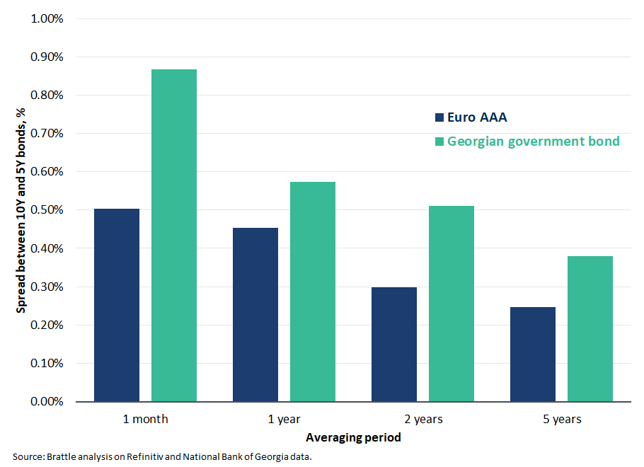
- Accordingly, we recommend ComCom to apply an upward adjustment of 60 basis point to the risk-free rate calculated using the one-year average yield of the Georgian 10-year government bonds. This 60 basis point adjustment reflects both the 40 basis points term premium to account for the historical spread between 20-year bonds and 10-year bonds in Europe and an additional 20 basis points to account for the higher term premium of Georgian bonds.
- Finally, we note that, in practice, many EU regulators continue to combine a risk-free rate based on a 10-year bond yield with an ERP based on DMS data. However, as we note above, this approach is inconsistent, and we would not recommend it. Other regulators that we have advised, for example the Dutch regulator ACM, have now chosen to use 20-year government bonds to ensure consistency with the ERP.

Calculation of the Risk-Free Rate for telecoms services in Georgia
- Based on the considerations above, we estimate the risk-free rate for Georgia based on the one-year average yield on the 10-year Georgian government bonds plus an adjustment of 60 basis points to reflect the spread between 20-year and 10-year government bonds.
- Figure 3, below, illustrates the evolution of the yields of 10-year Georgian government bonds over the past five years based on data published by the National Bank of Georgia.
- Over our one-year reference period, nominal government bond yields in Georgia have been increasing, passing from about 9.0% in late 2024, to just over 9.9% at the end of September, after some fluctuations. Overall, between 1 October 2024 and 30 September 2025, 10-year Georgian government bond yields averaged 9.1%. We cross-checked this value against an average calculated over a five-year period. This allows us to check for the impact of employing a different averaging window when calculating our risk-free rate.
- In general, the yield of 10-year Georgian government bonds showed some fluctuations over the last five years, with a maximum of around 10.8% in mid-2022, after the beginning of the war in Ukraine, and a minimum of around 7.1% in mid-2023. However, purely by chance for the period we examine, such fluctuations ultimately result in a five-year average of 9.0% that is broadly in line with the one-year average. Hence, for the period examined, the choice of a one-year average or a five-year average would not have a significant effect on the WACC. However, the five-year average may not be close to the one-year average for different historical periods or for future periods. Hence, we still recommend ComCom use a one-year average for the reasons given above.
Figure 3: Yield on 10-Year Georgian Government Bonds
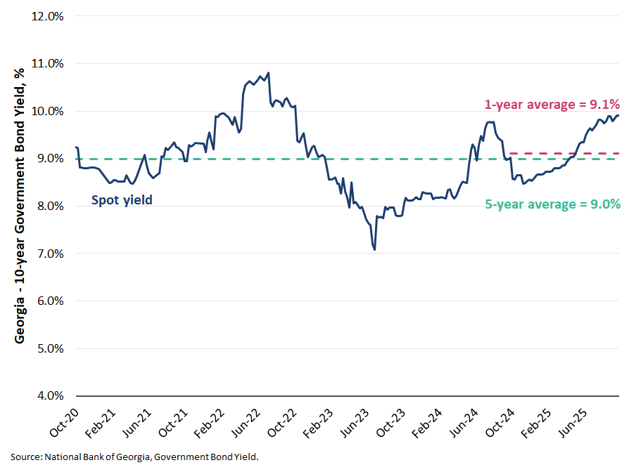
- Adding a 60 basis points adjustment to the one-year average yield of 9.1% results in a risk-free rate of 9.70%.
Table 3: Risk-Free Rate for regulated activities in Georgia

The Equity Risk Premium

Methodological Considerations
- There are two main issues to consider when estimating the ERP for telecoms services in Georgia:
  - First, whether to estimate the ERP on historical data or consider alternative approaches such as dividend growth models or surveys.
  - Second, whether the ERP for telecoms services in Georgia should reflect a world ERP, a regional ERP or a country-specific Georgian ERP, assuming such an ERP exists.
- We discuss these issues in turn before presenting evidence on ERP estimates in the following sections.

Methodology for Estimating the ERP
- The equity risk premium (ERP) measures the additional return, or premium, needed to compensate investors for the risk of holding risky equities, or shares, as opposed to holding a risk-free asset. Importantly, and unlike the risk-free rate, the ERP is not observable. For example, there is no traded product that will reveal the market’s expectation of the ERP. Regulators can only estimate the ERP, and any estimate will inevitably be subject to uncertainty and errors.
- Regulators generally estimate the ERP using historical data, by looking at long-run averages of the excess returns of stocks over bonds across countries. The fundamental idea of using past returns to estimate the ERP is that, in the very long-run, the actual excess return investors earned should correspond to the excess return they expected or required. While in any given year excess returns may be higher or lower than expected, in the very long-run these ‘surprises’ should even out. Also, long-run averages of excess returns tend to be stable and highly predictable, which are desirable properties in a regulatory setting. For example, adding one more year’s worth of data to a 125-year data series will not change the average much, even if the new value if quite different from the previous 125 values.
- The source of historical data that most EU regulators use is the annual publication by DMS which provides long-run estimates of the average realized ERPs from the 1900. The EC Guidelines also recommend estimating a European ERP based on historical data on the realized arithmetic average of the ERP for European countries. Consistent with the EC recommendations, BEREC calculates a European ERP taking the weighted average of the individual countries’ ERPs. BEREC relies on the raw dataset developed by DMS for countries for which data are available. BEREC also takes data from Bloomberg on investment returns in 14 additional European countries for which DMS does not publish an ERP. BEREC weights each country’s ERP taking into account both the length of the historical data series and the size of the market, which in turn considers both stock market capitalization and GDP.
- Alternative methods for estimating the ERP are dividend growth models (DGM), which reflect the implied premium resulting from current stock prices and assumed dividend growth rate, and survey data. DGMs, however, tend to be volatile and driven by assumptions, whereas survey data shows very large variability and is often driven by optimism or pessimism about the market outlook. For these reasons, the use of historical data is generally preferred to DGMs and survey data.
- Based on the above considerations, we recommend ComCom to estimate the ERP for telecoms services in Georgia based on historical data, also consistent with the EC Guidelines.

Geographic scope of the ERP
- A second important issue to consider when estimating the ERP is the geographic scope. In principle, there is no such thing as a ‘Georgian ERP’ or a US ERP. Rather, analysts measure a historical series of excess stock returns over bonds for a specific country and then combine these estimates to form an overall estimate of the ERP. For example, if the historical series of excess stock returns over bonds for Georgia was 6%, and the series for Germany was 4%, this does not mean that the ERP for Georgia is 6% and the ERP for Germany is 4%, for two reasons. First, the ERP derived from the data of one country will be statistically much more uncertain than the ERP derived from the data of 20 or 30 countries. That is, from a statistical perspective, the observed excess return of 6% for Georgia may not be statistically significantly different from the 4% excess return for Germany. That is, the true ERP for both countries could actually be the same. Second, if investors can invest in multiple markets, it is not clear why they would need a higher excess return for holding stock over bonds in Georgia than they would in Germany, given that the underlying bond yield (or risk-free rate) already accounts for Georgian country risk.
- At the extreme, if investors where perfectly diversified over the world, it would make sense to try and measure a ‘worldwide’ ERP. In practise, however, economists have found evidence of ‘home bias’. That is, investors have a tendency to invest more in markets to which they are geographically closer, or they are familiar with, and often with which the investor shares a common language. At the same time, it would be too extreme to suppose that investors only concentrated on their own country, and did not make investments outside.
- The EC Guidelines recommend EU member states to consider a European ERP. While Georgia has applied for membership, Georgia is not yet part of the EU. Hence, a question remains as the relevant geographic scope of the ERP for Georgia. In principle, one could consider countries that are similar to Georgia and try to estimate a weighted average ERP for those countries. As we discuss below, however, long-run historical data for such countries do not exist. This narrows down the calculation of the ERP to two options: considering a European ERP or a world ERP. In the next section we start considering the available historical ERP data and then explain that the difference between the ERP for Europe and the world ERP, if any, should be small. Accordingly, we recommend ComCom to select the value of the ERP selected by BEREC for the European Union.

Evidence on the ERP
- Table 4 below illustrates the realised arithmetic and geometric averages of the ERP for 35 individual countries taken from the 2025 DMS report. The table contains ERP estimates using data up to and including 2024 and specifies, for each country, the start year for calculation of the average.
Table 4: Historic Equity Risk Premium Relative to Bonds (1900 – 2024)
- As it can be noted from Table 4, DMS ERP estimates calculated using data from 1900 include mostly European countries, plus Canada, Japan, New Zealand, South Africa and the United States. Countries included in the dataset later, and mostly from the 1990s, include countries from Latin America, Eastern Asia and Russia. No ERP estimate is provided for Georgia.
- In effect, the available data narrows down the options for estimating the ERP to two options: considering a European ERP or a world ERP.
- In Table 5 we further analyse the evolution of the realized ERP for two groups of the 35 DMS countries – namely all European countries and all 35 DMS countries – and for two composite indices that DMS provides for Europe and the world. For the two groups of DMS countries, we construct market cap weighted averages of the individual countries’ ERPs based on DMS 2021-2025 publications. Table 5 further reports BEREC’s estimate of the ERP for Europe from BEREC’s 2021-2025 publications.
- Overall, we find that our market cap weighted average for Europe (5.9% in 2025) is in line with BEREC’s calculation for the European Union (5.9% in 2025), and lower than the weighted average for all DMS countries (6.8% in 2025). On the other hand, the DMS composite indices show a lower and similar value of the ERP for Europe and the world (4.6% in 2025). This evidence suggests that the difference between the ERP for Europe and the world ERP, if any, should be small.
Table 5: World and Europe Equity Risk Premium (2021-2025)
- Above we explained that there is no such thing as a ‘Georgian ERP’ and that estimating the ERP for telecoms services in Georgia based on a set of countries that are similar to Georgia is not feasible in practice, because long-run historical data for such countries do not exist. This left us with two options: considering a European ERP or a world ERP. However, the difference between a European ERP and a world ERP, if any, should be small. Importantly, there is no good theoretical reason why Georgia would have a higher ERP than average European countries. Also, the higher country risk of Georgia is already considered in the risk-free rate. Hence having a higher ‘Georgian’ ERP would risk double-counting such country risk.
- Based on the above considerations, we recommend ComCom to select BEREC’s estimate of the ERP for Europe from BEREC’s annual publication, as the methodology employed is transparent and provides an estimate that is reasonable and comes from an objective source. This approach results in a value of the ERP for telecoms services in Georgia equal to 5.9%.

Selection of the Peer Groups and Screening Tests

Potential Peers
- The beta parameter in the CAPM measures the systematic risk of a given investment. In other words, the degree to which returns in a given company’s stock would be expected to move with the returns of the market index. A beta of 1.0 means that, when the market index increases or decreases by e.g. 5%, the firm’s stock price is also expected to increase or decrease by 5%. A beta of more than 1.0 means that when the market index increases or decreases by e.g. 5%, the firm’s stock price is expected to increase or decrease by more than 5%, and a beta of less than 1.0 means that when the market index increases or decreases by e.g. 5%, the firm’s stock price is expected to increase or decrease by less than 5%. Stocks with a beta of more than 1.0 make a diversified investor’s portfolio riskier, and stocks with a beta of less than 1.0 make a diversified investors portfolio less risky.
- In selecting potential peers, we appreciate that Georgia is classified as an emerging market with a current credit rating of BB. Clearly, the economic and market conditions in Georgia will significantly differ from those in more developed markets. However, many of the additional risks that a telecoms company in Georgia faces, relative to a telecoms company in France or Germany are not systematic. For example, there may be additional regulatory or legal risks, but:
  - These risks will not be correlated with the wider economy and so are not systematic.
  - These risks should be largely accounted for in the relatively high level of the risk-free rate, which, as explained above, includes compensation for Georgian country risk.
- To the extent that there are non-systematic risks that are not covered by the Georgian risk-free rate, they should be compensated through cost allowances rather than through any adjustment to the cost of capital.
- Analysts routinely estimate betas by regressing the returns of a given firm’s share price against the returns of a market index. Hence, to estimate beta for a given firm or activity the firm, or firms that perform that activity, must be listed/publicly traded. However, the regulated Georgian companies in the telecommunications sector are not listed on a stock exchange. Therefore, to estimate the beta parameter, we need to find publicly traded firms with similar systematic risks. We refer to these companies as the ‘comparables’ or ‘peers’.
- In 2020, PwC considered a sample of 13 companies that own electric communication infrastructures, which included companies from Europe (10), China (1) and Russia (2). On the other hand, BEREC’s annual report regularly calculates betas considering only European peers. We create a ‘long list’ of peers by starting with the peer groups of companies considered in the PwC report and in the latest BEREC report, as well as the peer groups considered in prior Brattle reports for the telecoms sector, including three companies outside of Europe. From this group, we exclude the two Russian companies due to the lack of public trading and financial data. We also exclude Telenet Group Holding NV because it was delisted. We end up with a long list of 27 candidate peers.
- Because the regulatory framework under which a telecoms firm operates determines how the firm’s revenues and profits vary under different economic circumstances, it will be a key determinant of the firm’s systematic risk. For this reason, we should ideally select peers from countries with a broadly similar regulatory framework as the Georgian framework.
- We note that companies operating in EU countries share a similar regulatory framework with Georgia and should definitely be considered in the analysis. Also, the broad number of European peers already provides us with a large enough sample to obtain a robust beta estimate. On the other hand, we note that it is unclear whether the regulatory framework in China is similar to the regulatory framework in Georgia. Therefore, including betas of Chinese firms might not provide an accurate estimate of the beta for telecoms firms in Georgia. Accordingly, we recommend ComCom to estimate beta considering only the European peers.
Table 6: Potential Peer Group

Liquidity and other screening tests
- To obtain a reliable beta estimate, we apply several screening criteria to each of the candidate peers.
- First, we check that the stocks of the individual peers are sufficiently liquid. Illiquid stocks tend to underestimate the beta. Hence, for each of the potential peers in the initial sample, we test to see if the firms’ shares are sufficiently liquid. As a measure of liquidity, we consider the bid-ask spread measured as a percentage of the stock price and apply a threshold of 1% as a liquidity criterion. Accordingly, we calculate the average bid-ask spread as a percentage of the stock price over the reference period 1 October 2020 – 30 September 2025. As illustrated in Figure 4, the 1% cut-off does not lead to exclusion of any peers.
Figure 4: Bid-ask spread, 5-year weekly average
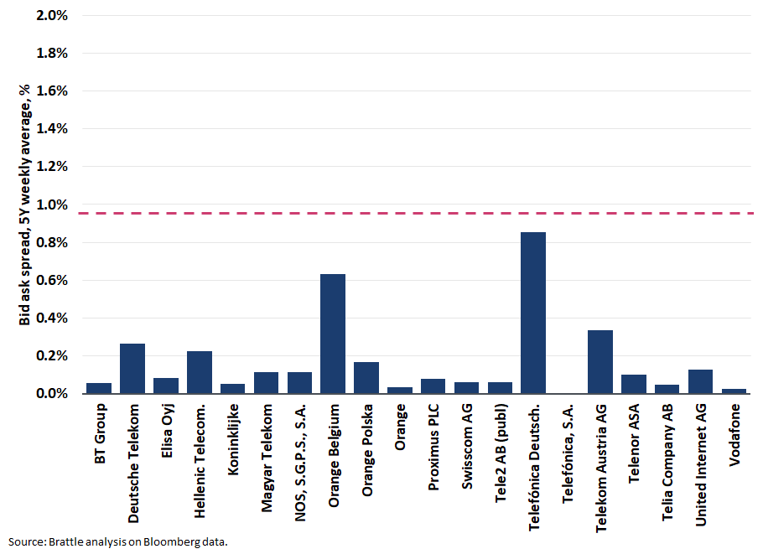
- We consider two additional screening tests to ensure a reliable beta estimate. Specifically, we check that the:
  - Credit rating of the candidate peers is not below investment grade. Share prices of firms with a low credit rating tend to be more reactive to company-specific news. This will lower the measured beta, in a way that may not be representative of the systematic risk of the companies. Based on this criterion, we exclude Digi Communications N.V. (rated BB-), Iliad SA (rated BB) and Telecom Italia S.p.A. (rated BB).
  - The companies were not involved in substantial M&A activity. Substantial M&A activity will tend to affect a firm’s share price in a way that is unrelated to the systematic risk of the business. Hence, the observed beta for a firm with substantial M&A activity will tend to underestimate the true beta for a firm with the same business activity absent M&A activity. Accordingly, we would exclude firms that have been involved in ‘substantial’ mergers and acquisitions (M&A) during the period for which data is used to calculate the beta. In practice we do not exclude any peers due to this criterion.

The Final Sample of Peers
- Table 7, below, lists the companies in the final sample. Overall, the final sample includes 20 European companies.
Table 7: Screening Tests Summary

Beta and Gearing

Methodological considerations
- The EC Guidelines recommend estimating equity beta using a five-year estimation window and weekly data frequency.
- As we explained in the 2016 Brattle Report, the choice of the estimation window involves a trade-off. On the one hand, a longer data series will increase the number of observations available for estimation, improving the precision of the estimate. On the other hand, however, extending the estimation window may fail to adequately capture changes in systematic risk over time.
- On balance, in 2016 we recommended using a two-year estimation window and a daily data frequency, largely due to concerns about rapid technological change. However, market developments over the last ten years have resulted in significant variations of the two-year betas relative to the five-year betas. Also, in recent projects on the calculation of the WACC for regulated companies we have seen that liquidity issues and other market imperfections tend to affect daily betas even when we restrict the sample to consider only firms that are relatively liquid.
- Given the above considerations, to check for stability and trends in beta we examine the evolution of both the five-year weekly and the two-year daily betas over the past five years through a rolling beta analysis.
- In addition, we apply a test to the two-year daily betas to correct for market imperfections. More specifically, we use the five-year weekly beta instead of the two-years daily beta, if it appears that share prices react to news the day before or the day after the market index reacts. This could occur because of differences in market opening times and trading hours, or differences in the liquidity of the firm’s shares relative to the average liquidity of the market. If such an effect is present, a beta estimated using daily returns on the firm’s share and on the market index may be biased. Similarly, financial market frictions caused by information asymmetries, transaction costs, limit orders, and overreaction to news may also affect the way information is incorporated in the share price. In contrast, weekly betas are less sensitive to the speed at which share prices assimilate information, because they use returns over five trading days.
- If the market is perfectly efficient, all information should be dealt with on the same day. The test for market imperfections is a variation of the Dimson test and requires regressing a company’s daily returns using the market index returns one day before and one day after as additional regressors (also known as the Dimson regression). If the lag or the lead coefficients are either significantly different from zero or jointly significantly different from zero, this suggests that information about the true beta may be lost by considering only the simple regression. This problem is addressed using five-year weekly data to estimate the equity beta.

Peer Groups Equity Betas
- We estimate equity betas for the peer group of firms by regressing daily and weekly returns of individual stocks on daily and weekly returns on the reference market index. We consider a two-year estimation window for daily returns and a five-year estimation window for weekly returns. We select broad industrial indices as the reference market index for each peer. Specifically, we use the STOXX Europe Total Market Index for European companies, the FTSE All-Share for UK companies.
- In Figure 5, below, we report the evolution of the median two-year and five-year equity beta of the peer group. The Figure shows a divergence between the two-year and the five-year beta early in 2022, when the beginning of the Covid pandemic dropped out of the two-year betas’ estimation window. After that, we observe a slowly declining trend in the two-year beta, while the five-year beta remained relatively stable. In early 2025, we observe a small drop in the five-year beta when the beginning of the Covid pandemic dropped out of the five-year estimation window. The drop, however, was relatively small relatively to the one observed for the two-year betas, and the median two-year and five-year betas continue to exhibit a gap, with the median five-year beta remaining about 0.10 higher than the median two-year beta.
Figure 5: Rolling betas, 5Y weekly vs 2Y daily
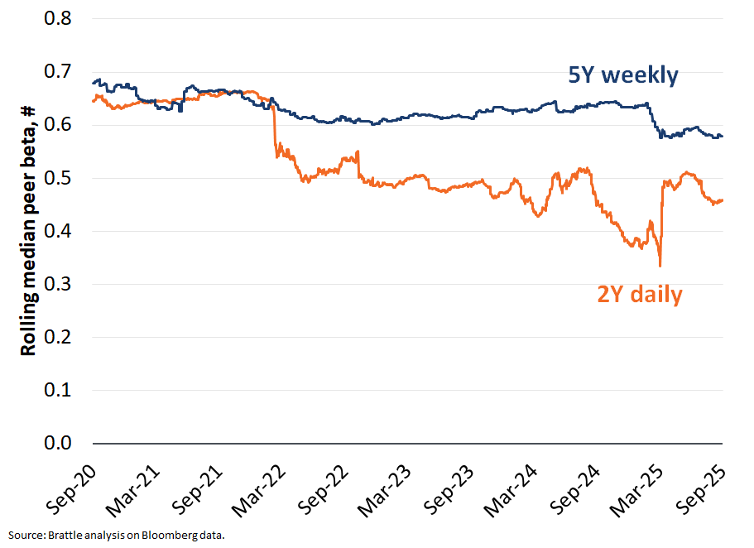
- There are several reasons that may explain divergence between the five-year weekly and two-year daily betas.
  - First, as explained above, there may be a residual liquidity issue that does not disappear even when we screen the sample of peers for liquidity. That is, even after trying to control for or filter out illiquid stocks, by excluding very thinly traded peers, some remaining liquidity frictions still affect the data. Because daily betas are more affected by these microstructure and timing effects, they will tend to be lower than weekly betas.
  - Second, shocks to the economy – including the Covid pandemic, the war in Ukraine, uncertainty about trade policy and the recent conflict in the Middle East – likely have had a stronger impact on the two-year daily betas. This is because the two-year betas are more affected by individual shocks to the economy than five-year betas. To the extent that recent shocks increased diversifiable risk, this would result in lower estimated two-year betas relative to five-year betas.
  - Third, the telecoms sector is characterized by frequent merger activity. Although our screening of sizeable M&A activity did not detect any large transaction with a visible effect on the volatility of the stock price, frequent merger activity may nonetheless depress daily betas.
- Taken together, the above issues provide support for using a five-year beta.
- In Table 8, below, we report the two-year daily and the five-year weekly equity betas for each individual peer. The Table also identifies with an asterisk two-year daily betas for which we have found evidence of market imperfections. In column [B], Table 8 further provides the adjusted daily betas, where we substitute the two-year daily betas with the five-year weekly betas in the presence of market imperfections.
Table 8: Equity betas
- Overall, the results confirm our expectations. The five-year weekly betas are generally higher than the two-year betas, and the adjusted two-year daily betas provide evidence of residual liquidity issues. Accordingly, we recommend ComCom to base the beta calculation on the estimated equity betas using five-year weekly data.

Peer Groups Gearing and Asset Betas
- As well as reflecting the systematic risk of the underlying business, equity betas also reflect the risk of debt or financial leverage. As debt is added to the company, the equity will become riskier as more cash from profits goes towards paying debt in each year before dividends can be distributed to equity. With more debt, increases or decreases in a firm’s profit will have a larger effect on the value of equity. Hence if two firms engage in exactly the same activity, but one firm has more debt, that firm will have a higher equity beta than the firm with less debt.
- To measure the relative risk of the underlying asset on a like-for-like basis it is necessary to ‘unlever’ the betas, imagining that the firm is funded entirely by equity. The resulting beta is referred to as an asset beta or an unlevered beta. Consistent with the recommendations of the EC Guidelines, we unlever the equity betas using of the Modigliani and Miller formula and a debt beta.
- We calculate the gearing of each peer taking the average of quarterly gearing ratios over the same time horizon used to estimate the beta. We calculate the quarterly gearing ratios by dividing quarterly net debt over quarterly market capitalization.
- As a measure of debt beta, we select a value of 0.1 for all peers. We note that, in principle, the debt beta of the peers varies with their risk of default. In practice, however, the rating of the peers fall within a narrow range – between BBB- and A- – and the EC Guidelines recommend using a single value of debt beta to reduce complexity and improve transparency.
- Table 9, below, reports the equity beta, the gearing and the resulting asset betas for each peer. The Table further reports the average and median gearing and asset betas for the sample. Overall, we find that the asset beta ranges between 0.17 and 0.70, with a median asset beta of 0.40. The gearing ranges between 10% and 179%, with a median gearing of 71%.
Table 9: Equity betas and asset betas

Gearing and Asset Beta for the Telecommunications Sector in Georgia
- We calculate the WACC for the Telecommunications sector in Georgia using the 5-year weekly estimations of the median asset beta and median gearing of the European peers. Table 10 summarizes the results.
Table 10: Asset beta and gearing for telecommunications in Georgia

The impact of country size on Telecommunications operators’ systematic risk
- ComCom has further asked us to consider whether the WACC of telecoms operators in Georgia may be affected by the relatively small size of the Georgian market.
- The relatively small size of the Georgian market could potentially affect the systematic risk of telecoms operators. In other words, it could affect beta. To evaluate this potential impact, we have analysed the relation between the estimated betas and demographic variables including land area, population and GDP per capita. Intuitively, a larger area could involve higher investments and risk, everything else equal. Conversely, a higher population might increase economies of density and reduce risk. Similarly, higher GDP per capita might imply a lower price sensitivity of consumers.
- More specifically, we consider the following regression model:
$${Beta5Y}_{i}= β_{0}+β_{1} {Population}_{i}+β_{2} {Land area}_{i}+β_{3} {GDP per capita}_{i}+ ε_{i}$$
- Where:
  - The dependent variable ${Beta5Y}_{i}$ represents the 5Y weekly asset beta of each telecoms operator $i$.
  - ${Population}_{i}$ – our first variable of interest – represents the population of the country of incorporation of each telecoms operator $i$, measured in log.
  - ${Land area}_{i}$ – our second variable of interest – represents the land area of the country of incorporation of each telecoms operator $i$, measured in log.
  - ${GDP per capita}_{i}$ represents the GDP per capita of the country of incorporation of each telecoms operator $i$, expressed in 2015 USD and measured in log.
- The regression calculates the impact on the asset beta of a hypothetical variation in country size, measured as population and land area, controlling for GDP per capita. We expect that, if country size affects the systematic risk of telecoms operators, the regression result yields coefficients that are statistically significant for the explanatory variables of population and land area.
- Table 11 reports the results of the regression. Overall, we find no evidence of a statistically significant relation between land area and population and a firm’s beta. None of the regression coefficients are statistically significant, indicating that land area and population do not affect beta. Hence, we conclude that there is no impact of country size on the systematic risk of telecoms operators and, as a result, there is no need to adjust the asset beta to account for Georgia’s relatively small size.
Table 11: Regression results of populations and country size on asset beta
- We note that during the public consultation, one of the stakeholders claimed that:
  - companies with a lower market capitalisation had higher betas, because their smaller size meant that they were more vulnerable to systematic shocks;
  - The companies in our peer group had a higher market capitalisation than the Georgian operators, with the results that our analysis would underestimate the beta for Georgian telecoms operators.
- As noted above, the area to be covered, the population to be served and the average GDP per capita are relevant to the deployment and operation of a telecoms network. In contrast it is not clear why a higher or lower market capitalization should affect the systematic risk of a telecoms operator, and specifically the relationship between the operator’s returns and the return on the index, which is what beta measures. The above notwithstanding, we have run a regression of the estimated 5-year betas on the market capitalization of the companies in our sample, measured in thousands of Euros.
- Table 12 reports the results of the regression. We find no evidence of a statistically significant relation between market capitalization and a firm’s beta. The estimated coefficient is very close to zero (close to ${10}^{-7} in absolute value$) and not statistically significant. We conclude that our analysis does not underestimate the beta for Georgian telecoms operators.
Table 12: Regression results of Market Capitalization on asset beta

Cost of Debt

- In 2020, PwC calculated the cost of debt as the sum of a debt premium over the risk-free rate. The debt premium, in turn, was calculated by subtracting the risk-free rate from the one-year average interest rate on corporate loans in Georgia, as published by the National Bank of Georgia.
- In contrast, the EC Guidelines recommend calculating the cost of debt as the sum of the risk-free rate plus a debt premium, both calculated based on five-year averages. The EC Guidelines recommend calculating the debt premium based on the spread between long-term corporate bonds with maturity as close as possible to 10 years and national government bonds of similar maturity. Consistent with the EC Guidelines, BEREC calculates annually operator-specific debt premia using secondary market data on yields for bonds issued by the individual operator and domestic risk-free rate, striving for a maturity of 10 years and with a five-year averaging window.
- To develop a robust methodology and arrive at a reasonable cost of debt calculation we consider four alternative approaches.

Alternative measures of the cost of debt for Georgian Telecoms Operators
- First, we consider the methodology used by PwC. Table 13 reports the calculation of the debt premium using the PwC methodology and data from the National Bank of Georgia (NBG) as of September 2025. Overall, we find that the one-year average interest rate on corporate loans in Georgia as of September 2025 was equal to 12.91%, implying a 3.81% premium.
Table 13: Cost of debt – PwC’s approach
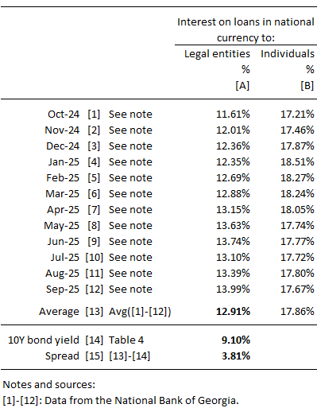
- The methodology has the advantage of calculating directly the debt premium for companies operating in Georgia. However, because it considers all loans issued by companies in Georgia, there is a risk that the resulting debt premium overstates the cost of debt of telecoms operators in Georgia. This is because the debt premiums likely included unsecured debts, which are higher risk and so attract higher interest rates. In contrast, telecoms operators can borrow against assets, so have secured debt. Telecoms operators are also larger than the average company in Georgia. The cost of debt tends to fall with size, because fixed debt arrangement costs are spread over a larger loan. Hence telecoms operators are likely to obtain better rates than the average borrower in Georgia.
- Second, we calculate the debt premium taking the difference between the embedded cost of debt of operators in Georgia as recorded in their annual accounts and the contemporaneous risk-free rate. We then calculate the embedded cost of debt of telecoms operators in Georgia extracting information on interest expenses and outstanding debt balances from the financial statements of Cellfie and Silknet. We do not calculate the embedded cost of debt of Magticom because the company does not hold any interest-bearing debt.
- Table 14 reports the data on interest expenses and outstanding debt collected from the operators’ financial accounts and the corresponding estimates of the embedded cost of debt over the past five full calendar years (2020-2024). We find that, on average, Georgian telecommunications operators have faced a cost of debt of 11.10% over the period 2020 to 2024. This corresponds to an average spread of 2.00% over the contemporaneous yield on 10-year Georgian government bonds. We further note that the spread is quite volatile from year to year, ranging from a low of -0.06% in 2022 to a high of 3.26% in 2021, likely reflecting the effect of large bond issuances or principal repayments. Such volatility supports the use of a longer averaging period, e.g. five years, instead of taking a short-term average.
Table 14: Cost of debt – embedded cost of debt approach
- Consistent with our expectations, the spread of 2.00% calculated based on embedded cost of is significantly lower than the 3.81% spread calculated based on the PwC methodology, likely reflecting the better terms telecoms operators are able to obtain relative to the average firm in Georgia.
- This methodology has the advantage that it calculates the debt premium paid by the operators in Georgia directly from the companies for which we are calculating the WACC. On the downside, however, the sample is small as there are only two companies. Moreover, the financial statements report interest on debt issuances on currencies other than the Georgian Lari – for example US dollars and Euros. Interest rates based on such ‘hard’ currencies’ which have lower inflation risk than the Lari, will understate the operator’s actual cost of debt in Georgian Lari. While we could isolate the debt in Georgian Lari in the operator’s accounts to obtain a Lari interest rate, we find that rates from these loans are even more volatile than the overall rate, and in some years there is no Lari debt at all.
- We note that an analysis prepared by one of the stakeholders estimated a currency risk premium of one percentage point to convert Euro-dominated debt to Georgian Lari debt. If we adopted the same approach, we would estimate a debt spread of 3.00%. We note that, all things equal, this adjustment will tend to overstate the cost of debt because we add the currency risk premium to all debts, even though some of the debts are denominated in Lari. Hence, 3.00% is an upper limit.
- Third, we consider the debt premia paid by European telecoms operators as calculated in the BEREC annual reports. Table 15 summarizes the debt premia reported in the 2025 BEREC report. Overall, we observe that debt premia paid by European telecoms operators range between 0.53% for Telefónica and 3.05% for DIGI Communications, with an average of 1.34%. We further note that the debt premium for companies below investment grade is significantly higher than the average, with Telecom Italia (BB) at 2.23% and DIGI Communications (BB-) at 3.05%. The average between the spreads calculated for Telecom Italia and DIGI Communications is equal to 2.64%.
Table 15: Cost of debt - BEREC
- Finally, NBG publishes the estimated interest rates or yields for Georgian BB rated debt denominated in Lari for different maturities – a ‘BB Corporate Curve’. We understand that NBG calculates the BB Corporate Curve by adding a spread to the yield curve for Georgian government bonds, also in Lari. As of 30 September 2025, corresponding to Brattle’s measurement date, NBG estimated the yield on 10-year BB Georgian corporate bonds in Lari at 14.35%. By subtracting the contemporaneous 10-year government bond yield we derive an implied spread of 4.44%.

Conclusions on the Cost of Debt
- In Table 16 below we compare the spread, and the resulting cost of debt, calculated using the alternative measures of the spread calculated in the previous section.
- We note that the spread resulting from the BB Corporate Curve (4.44%) is significantly higher than the average spread for corporate loans in Georgia (3.81%) – which was the measure considered in the last regulatory period. This is highly surprising, as we would expect rated bonds to command lower yields or interest rates than non-traded corporate loans. Possible explanations of this result may be attributable to sample selection as well as liquidity and size issues. However, we do not have sufficient information to make sense of this difference. We also note that the estimated spread of 4.44% from the BB Corporate Curve is also significantly higher than the highest spread calculated for telecoms operators by BEREC, equal to 3.05%. Based on the considerations above, we conclude that the BB Corporate Curve does not provide a reliable data point for the cost of debt of telecoms operators in Georgia.
- As noted above, we consider that the previous method, based on interest rate data from the NBG, is likely to overstate interest costs for Georgian telecoms operators. The firms are likely to be larger than the average firm size in the NBG sample, and can obtain lower rates by borrowing against assets.
- We also find that the cost of debt rate estimated from the operators accounts is problematic, because the data includes debt issued in foreign currencies while the data for debt in Georgian Lari is patchy and volatile. The estimated spread of 2.00% is likely to understate the operators’ actual cost of debt in Georgian Lari. Similarly, the spread of 3.00% calculated by adding to the estimated spread a 1% currency risk premium to convert Euro-dominated debt to Georgian Lari debt only provides an upper bound to the operators’ actual cost of debt, because some of their debt is already in Georgian Lari.
- Hence, we conclude that deriving a cost of debt from the BEREC data will likely give the most reliable estimate of the cost of debt for Georgian operators. However, we note that Cellfie and Silknet are rated BB- and B+, respectively. These ratings are lower than those of most European peers, indicating a higher level of credit risk. This strongly suggests that using the BEREC average debt premium of 1.34% would understate the true cost of debt for Georgian telecoms operators. The cost of debt faced by Georgian operators is likely higher than the benchmark estimate of 1.34%, and more in line with the debt premia paid by companies such as Telecom Italia and DIGI Communications being 2.23% and 3.05% respectively. Hence, we estimate the cost of debt based on the average spread for Telecom Italia and DIGI Communications, the lowest-rated operators in the BEREC sample, equal to 2.64%. This yields a debt spread of 2.64%.
Table 16: Cost of debt for telecommunications operators in Georgia
- We note that a debt spread of 2.64% is higher than the 2.00% derived from the companies accounts, but lower than the 3.00% we obtain if we adopt the currency risk adjustment proposed in the stakeholder analysis. This is reasonable, because the appropriate level of the spread should lie somewhere between these two values.
- Adding a 2.64% spread to the risk-free rate results in a cost of debt of 11.74% on a pre-tax basis, or 9.98% on an after-tax basis.
- We note that our calculated cost of debt is higher than the cost of debt of 10.84% estimated by the stakeholder analysis. This is true even if we include the proposed maturity adjustment, with which we disagree. The analysis estimated a cost of debt for Cellfie of 13.42%. However, the maturity adjustment accounts for 2.08% of the cost of debt. Removing this premium Cellfie’s cost of debt is 11.34%, slightly lower than the cost of debt we estimate.

Relevance of an NGA premium in the Telecoms sector in Georgia

- ComCom has further asked us to assess whether a premium on the WACC should be applied for investments in next-generation access (NGA) networks, including the fixed fiber network and the 5G network. We first review the regulatory precedent and evidence on the premium for investments in the fixed fiber network (section VIII.A) and then provide our recommendation on the relevance of a WACC premium for investments in NGA networks in Georgia (section VIII.B).

Review of regulatory precedent and evidence on the fiber premium
- The notion of a fiber premium in the economic regulation of telecoms networks dates back to EC Recommendation 2010/572/EU of 20 September 2010 on regulated access to NGA networks. In the Recommendation, the European Commission recommended, for the purposes of calculating tariffs, that the WACC of the SMP operator in EU member states should reflect the higher risk of investments in fiber relative to the risks of operating the copper network.
- To this end, recognizing that the development of fiber networks, especially in their initial phases, entails significant risks due to high irreversible investment costs and demand uncertainty, the Commission recommended that NRAs incorporate a risk premium into the WACC, including, where justified, a fiber premium over the WACC for the copper network. In calculating this fiber premium, the Recommendation recommended NRAs to consider uncertainty factors related to demand, costs of deployment, technological progress, and market dynamics. Since these factors vary over time, and reasonably decline as the coverage of the new NGA network increases, NRAs must periodically review the situation and adjust the risk premium over time, taking into account changes in these factors.
- The rationale for including a fiber premium for fiber investments compared to the WACC for copper networks was further analysed in our 2016 study commissioned by the European Commission at the start of the process of harmonizing WACC calculation methodologies. The study identified three main reasons why the WACC for NGA networks could be higher than the WACC for copper networks:
  - Capital leverage: The fiber business requires large investments to build fiber networks. Commitments to make large investment may increase beta, since they are a commitment for cash flows, and increase the volatility of returns.
  - Demand uncertainty: demand for fiber services may be more sensitive to changes in economic performance and income. This could be the case, for example, if fiber demand could be seen as a premium product.
  - Long-lived assets: new fiber assets are long-lived, and so their value will be more sensitive to changes in macroeconomic conditions than a copper network, which has a shorter remaining lifetime.
- A further reason to recognize a fiber premium, attributable to EC Recommendation 2010/572/EU and accepted in practice by some EU regulators, relates to the irreversible nature of investments in fiber, whereby the SMP operator making the investment in fiber effectively foregoes the value of the option to postpone the investment decision to a later date, and for this it must be remunerated.
- Consistent with the recommendations of EC Recommendation 2010/572/EU, several NRAs have analysed the relative risk of fiber investments compared to copper networks. These analyses identified the need to include a Fiber Premium to compensate for the increased risk of new investments in fiber, noting, however, that the increased risk of such investments, and the associated additional remuneration required, should decrease with the rollout of the network. In subsequent market analyses, several regulators have reduced the fiber premium to account for the lower risk of fiber investments due to the increased coverage of the new NGA network. In some cases, regulators have removed the regulation of NGA network access altogether, having determined that the basis for ex ante regulation was no longer present.
- In Spain, for example, in 2013 the CNMC introduced a 4.81% premium on the WACC for broadband services with speeds above 30 Mbps. The CNMC calculated the premium based on a financial model, equal to the difference between the internal rate of return (IRR) of a fiber investment and the IRR of a copper investment. Subsequently, starting in 2016, the CNMC removed ex-ante regulation of fiber service, limiting the SMP operator's price control to replicability tests.
- In the UK, Ofcom introduced a 2.2% WACC premium for fiber network services over copper in 2014, giving fiber investments a higher asset beta (0.83) than copper investments (0.50). Specifically, in calculating the WACC for incumbent operator BT's fiber services, Ofcom decomposed BT's beta into the beta of the various regulated activities. Ofcom estimated two separate asset betas, one for access to Openreach's copper network and one for all other regulated telecoms services, including fiber, believing that the systematic risk for fiber was similar to the systematic risk for other mobile and broadband telecommunications services, both retail and wholesale. The Fiber Premium was subsequently reduced to 0.9% in 2018 and 0.8% in 2021.
- In the Netherlands, the regulator ACM set a Fiber Premium of 2% in 2015, which it subsequently reduced to 0.8% in 2020, noting that this reduction was justified by a reduction in demand uncertainty, due to increased penetration and take-up of the new network, and by a reduction in investment costs.
- In France, in 2015, ARCEP adopted symmetric regulation for fiber networks – that is, regulation that would apply to any operator, and not only to the SMP operator – and developed a reference financial model to be used as a tool for calculating fiber network tariffs. The financial model approved by ARCEP used an indicative duration of 25 years and identified a fiber premium in the form of a 5% increase in the WACC compared to the copper network. The fiber premium was defined as the difference between the regulated WACC used for the copper network and the project IRR expected for a broadband network. However, the Fiber Premium to be applied to the tariffs of each project was not defined ex ante but had to be assessed on a case-by-case basis using the model developed by ARCEP, adapted to the technical and financial specifics of each project. The fiber network service was subsequently deregulated, making the application of a fiber premium irrelevant.
- In Italy, AGCOM first calculated a fiber premium of 3.2% in 2015 using an option pricing model to estimate the option value of waiting instead of making an investment in the NGA network today. This figure was confirmed in the subsequent market analysis and remained unchanged until 2021. The fiber premium was then reduced to 1.92% in 2022 and 1.36% in 2023. For the regulatory period from 2024 to 2028, AGCOM has decided that the application of an NGA premium is no longer justified because it expects FTTH coverage will be reasonably complete by 2028, eliminating the uncertainty that gave rise to the option premiums. During the ongoing market consultation, AGCOM has proposed to remove the price control obligation altogether.
- Figure 6, below, illustrates the values of the fiber premiums ​​currently in effect in in the European Union and the United Kingdom, and identifies countries that do not apply a fiber premium or where fiber services are unregulated. Overall, only 7 NRAs currently maintain a Fiber Premium in the WACC for fiber networks, with an average premium of 1.45%. The other NRAs, including those in countries with the highest FTTH coverage, initially regulated FTTH services and then decided that regulation was no longer necessary, or do not apply a fiber premium even though the service is regulated. The NRAs that apply a fiber premium have estimated this premium either based on a financial model (France, Italy and Spain), based on an asset beta differential (United Kingdom, Belgium, Netherlands), or as an average of the premiums adopted by other countries (Poland, Slovenia, Croatia, Czech Republic).
Figure 6: Current Fiber Premiums Selected by European Telecoms Regulators
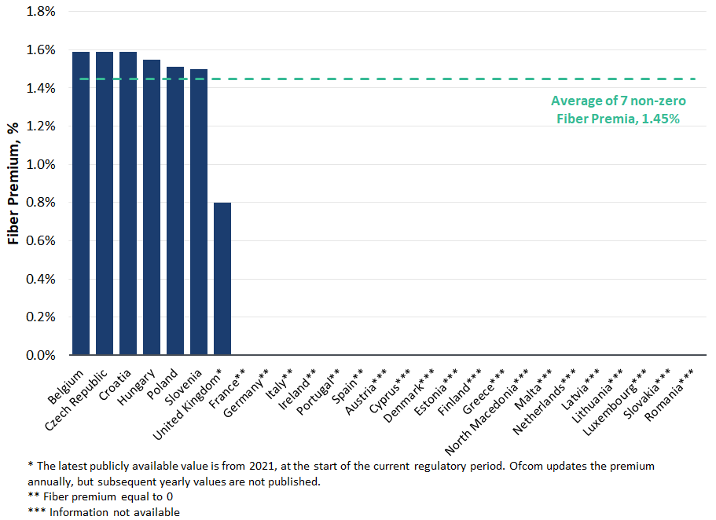
- In Figure 7 below, we further illustrate the fiber premiums which were initially selected by the regulators at the time they were introduced. Overall, these initial fiber premiums ranged between 0.61% in Slovenia and Luxembourg and 4.81% in Spain, with an average of 2.39%.
Figure 7: Initial Fiber premiums selected by European Telecoms Regulators

- Evidence on the decline over time of the higher risk of investments in fiber, due to the combination of increased coverage, reduced demand uncertainty and a matured technology, is also provided by the analyses we have performed in prior reports prepared for the Dutch regulator ACM and the UK regulator Ofcom, which the regulators used as a basis for updating the value of the fiber premium. In these reports, we suggested that the higher systematic risk of investments in fiber could be captured directly, by looking at the difference between the asset betas of “incumbent operators”, which are the owners of the legacy copper network in at least one of the countries in which they operate, and “alternative operators” of a fixed telecom or cable network competing with the national incumbents. We have replicated that analysis recently, in the context of calculating the WACC for heating networks in the Netherlands and in preparing this report for ComCom.
- In Table 17, below, we summarize the results of the comparison between the betas of incumbent operators and the betas of alternative operators at four different points in time, corresponding to the measurement dates we used in the above mentioned reports for the ACM and Ofcom and in this report. In more detail, the table reports the median asset beta of incumbents and alternative operators and the difference between the two. The table further reports the measurement date and the methodology applied for the analysis. Overall, we find evidence of a decline over time in the differential of the beta between incumbents and alternative operators, from more than 0.10 in 2019-2020 to as low as 0.01 in 2025. The differential, however, appears volatile, and we cannot exclude that investments in fiber still involve a higher systematic risk than operating the copper network.
Table 17: Median asset betas of incumbent and alternative operators
- The recommendations of EC Recommendation 2010/572/EU regarding the applicability of a fiber premium are still relevant in the current regulatory framework. However, recent developments seem to stress the importance of a project-specific, case by case determination of the WACC premium which may be recognized for the development of very high capacity networks (VHCN), but only in the presence of quantifiable risk. In particular, the 2019 Commission WACC Notice explicitly refers back to the 2010 NGA Recommendation, which remains the primary reference for assessing whether additional remuneration is justified for fiber roll-outs. Furthermore, both the BEREC’s 2025 Report and the 2024 Gigabit Recommendation of the European Commission continue to distinguish between the WACC applicable to the legacy infrastructure – which must be calculated according to the WACC Guidelines – and the additional, project-specific risk premium that NRAs may apply on top of the baseline WACC where the deployment of new VHCNs entails additional and quantifiable risks. Therefore, consistently with the 2010 EC Recommendation, the current framework confirms that such a premium remains appropriate for specific fiber investment projects, should they transparently reflect incremental risk.

Recommendation on the relevance of a WACC premium for investments in next-generation networks in Georgia
- As explained in the previous section, the capital leverage, demand uncertainty and long-lived nature of investments in new fiber assets may justify the provision of a WACC premium, particularly in the early years of the investments. However, the case for allowing a premium reduces over time, and no premium should be applied when the investments have been completed and demand uncertainty is resolved.
- In Figure 8 below, we illustrate the evolution of the share of subscribers by technology in Georgia over the last 10 years. The Figure clearly shows that the share of fiber subscriptions has steadily increased to almost 90% in 2025. Importantly, the share attributable to the legacy copper networks has shrunk to low single digits since 2020.
Figure 8: Fiber Penetration of Georgian Internet Market
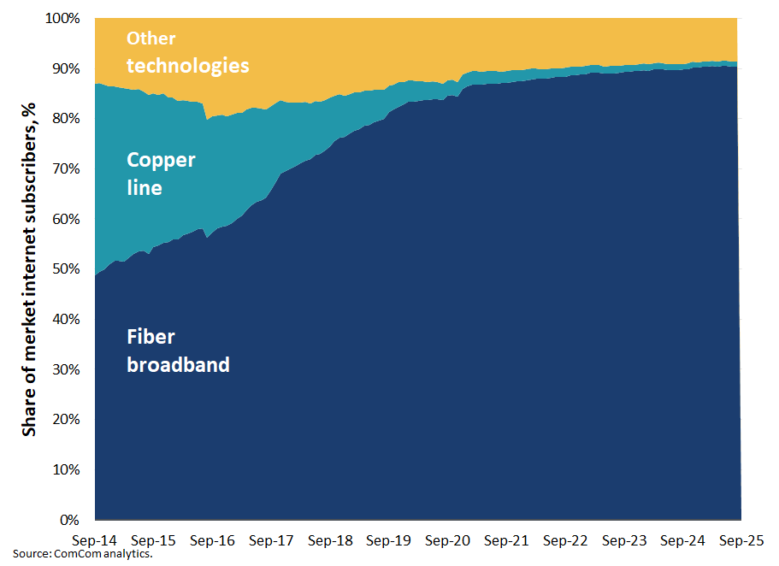
- Clearly, as the Figure above suggests, the deployment and adoption of the fiber network is extremely high in Georgia, which makes the application of a general fiber premium to the WACC for existing fiber assets no longer relevant. For existing assets investments have been made and demand uncertainty has been positively resolved.
- However, as of today many fiber connections in Georgia are still fiber-to-the-building (FTTB) and over 90% of subscriptions have connection speeds of 70 Mbps or lower. Importantly, significant investments will need to be made to improve connection speeds across the country, in line with Georgia’s national broadband plan, including for upgrading existing FTTB connections to fiber-to-the home (FTTH) and for deployment of the fiber network in rural areas. Also, in the mobile market, all three operators have acquired 5G licenses over the period 2023–2025. However, only one operator has deployed 5G nationwide, while the other two still need to undertake significant investments to expand coverage and improve connectivity.
- We note that the above considerations about the applicability of a fiber premium naturally extend to the deployment of the 5G network and, more broadly, to the undertaking of any significant investment project to upgrade or expand the existing fixed and mobile telecoms networks. This is because the capital leverage argument is generally true of any commitment to make large investments. Similarly, demand uncertainty is typical of any technology upgrade, where there is uncertainty about the adoption of the new technology from end users and their willingness to pay for the technology upgrade.
- Accordingly, and consistent with the recent developments of the regulatory framework in Europe, we recommend ComCom to apply a fiber premium for:
  - Investments in network upgrades. This shall include investments for upgrading of FTTB connections to FTTH and any related upgrade of the primary network and equipment. This may also include large network upgrades aimed at increasing the overall throughput capacity of the network and/or reduce the number of users per shared network element, ultimately resulting in the possibility to provide higher connection speeds for the end users.
  - Investment in new infrastructure development, such as deployment in rural areas, where a fiber network does not yet exist and/or where other technologies are currently in use.
  - Investment in 5G and future generation mobile.
- For the investments falling under items a.-c. above, ComCom should apply the NGA premium in calculating tariffs in any relevant wholesale market which may be defined, analysed and regulated by the ComCom during the regulatory period.
- As regards the size of the applicable premium, we recommend ComCom to consider the range of values of the fiber premiums selected by European regulators.
  - If we consider the values which were initially selected as the fiber premia were introduced, we observe premiums in the range 0.61%-4.81%, with an average of 2.39%. We note, however, that relative to the period in which these premia were selected, fiber technology has matured and consumer demand for high-speed connectivity has increased substantially. Therefore, the risk of investments in fiber has likely reduced.
  - If we consider the values of the fiber premiums currently applied, we observe values in the range 0.80%-1.59%, with an average of 1.45%. These premiums, however, are applied to all investments in fiber, including existing assets and new investments. Therefore, these premiums may not adequately remunerate the additional risk of new investments in fiber.
- Based on the above considerations we would recommend ComCom to select a value of the fiber premium of 2%. This value is lower than the 2.39% average of the premiums initially selected by European regulators, reflecting the lower risk of investing in fiber today as the technology has matured and demand has increased. At the same time, this value is higher than the average premium of 1.45% currently applied in Europe to remunerate new investments in fiber and existing fiber assets, reflecting the need to provide a higher premium in the remuneration of new investments.
- We note that, as an alternative, ComCom could rely on a detailed financial model – as was done by the NRAs in France, Italy and Spain – to calculate the premium as the required premium that would compensate the operator for the higher risk of investing in fiber now. However, developing such type of model can be complex, and the results would ultimately be driven by the underlying assumptions about different take up scenarios and prices. Given the complexity and the dependence on assumptions, we do not see any real advantage of ComCom developing a financial model relative to selecting a value of the premium based on the benchmark at this time.

Application of a different WACC for mobile and fixed Telecommunications operators
- ComCom has further asked us to assess whether the WACC should be differentiated or not for mobile and fixed telecoms services.
- Although the systematic risk of operating a fixed network may potentially differ from the systematic risks of operating a mobile network, there are three main reasons why a differentiation of the WACC may not be advisable nor feasible in practice.
- First, there is technological convergence. Fixed and mobile networks are increasingly substitutable from a demand side perspective and increasingly used for data traffic purposes. Also, on the supply side, mobile networks have become more similar to fixed networks in that they are now use higher frequency bands which require a significantly higher number of cells. Technological convergence is also expected to increase with the deployment of 5G, which supports unified fixed and mobile core networks. This implies that the potential difference in systematic risk, if any, is likely shrinking.
- Second, all telecoms firms in the sample of peers are integrated fixed and mobile operators, so that a separate beta for fixed and mobile cannot be estimated. In other words, there are no “pure player” fixed and mobile operators based on which we could estimate the beta for fixed and mobile services.
- Third, we are not aware of any regulator applying a different WACC for mobile services. Effectively, regulators either apply a common WACC for fixed and mobile services or do not apply any WACC for mobile services because there is no price control for these services.
- Based on the considerations above, we recommend ComCom to apply a common WACC to regulated fixed and mobile services.

WACC

- Based on the preceding calculations and discussions, Table 18 details our calculation of the nominal pre-tax WACC for the regulated activities of electronic communications in Georgia.
Table 18: WACC for the telecommunications sector in Georgia

ComCom, “On Amendments to the Decision of the Georgian National Communications Commission of September 5, 2017 N592/9 On Determining the Weighted Average Cost of Capital (WACC) for Mobile and Fixed Networks”, G-22-19 / 306, 8 July 2022 (available at: https://comcom.ge/ge/legal-acts/solutions/2022--22-19-306.page). Hereafter, “ComCom 2022 decision”.
PwC, Consultancy Services to review and update Accounting Separation Guidelines and development of review and recalculation of WACC: WACC Methodology and preliminary results”, December 2020 (available at: https://comcom.ge/uploads/other/9/9651.pdf). Hereafter, “PwC 2020 Report”.
European Commission, “Commission Notice on the calculation of the cost of capital for legacy infrastructure in the context of the Commission’s review of national notifications in the EU electronic communications sector,” 2019/C 375/01, 6 November 2019. Hereinafter, “EC Notice on WACC”.
For example, BEREC, “BEREC Report on WACC parameter calculations according to the European Commission’s WACC Notice of 6th November 2019”, June 2025. Hereinafter, “BEREC’s 2025 report”.
EC Notice on WACC, ¶¶31, 35, 65.
See Brattle 2016 Report, §VI.A.4, pp. 41-43.
BEREC’s 2025 report, p. 24.
In other work, we have considered that seven to ten peers should be sufficient to give a reliable beta estimate. Of course, there is always a trade-off between a larger number of peers, and whether the peers in the sample accurately reflect the business for which we are estimating a beta. Arguably, it is better to have a small sample of firms that are engaged in the relevant business than a larger sample of firms that derive significant revenue from businesses that differ from the one for which we are estimating beta.
EC Notice on WACC, ¶56.
BEREC’s 2025 Report, pp. 26, 27.
We note that in future updates to the WACC, Georgia telecoms operators may have traded bonds with reported yields. If this is the case, then ComCom could combine data from these yields with appropriate spreads from the BEREC report.
Based on data provided by ComCom.
For avoidance of doubt, these markets will include (1) wholesale access to communication ducts (ComCom main Decision - 620/9 06.11.2014 with all amendments), (2) wholesale access to Internet resources (ComCom main Decision -57-9 29.01.2015 with all amendments), (3) wholesale leased lines (ComCom main Decision - N671/9 06.12.2018 with all amendments), (4) wholesale local and central access at a fixed location (ComCom main decision 9/361,08/08/2024 with all amendments), (5) 5G mobile network Wholesale services, and any other relevant wholesale market which may be defined, analysed and regulated by the ComCom during the regulatory period.
EC Notice on WACC, ¶¶31, 35, 65.
For a discussion on this issue see Dan Harris, Richard Caldwell, Lucia Bazzucchi, and Francesco Lo Passo. “Review of approaches to estimate a reasonable rate of return for investments in telecoms networks in regulatory proceedings and options for EU harmonization”. Prepared for European Commission, DG Communications Networks, Content & Technology, 2016 (“Brattle 2016 Report”), §VI.A.1, p. 24. See also EC Notice on WACC, ¶34 and BEREC’s 2025 Report, §2.2, pp. 14-15.
See Brattle 2016 Report, §VI.A.4, pp. 41-43.
For instance, in 2022 the Spanish regulator CNMC estimated the risk-free rate by averaging the five-year and six-month yields on ten-year government bonds, in order to better reflect current macroeconomic conditions at the end of QE. The European Commission considered this methodology acceptable, noting that regulators may depart from the Guidelines when duly justified and aligned with regulatory objectives (see Commission Comments, Case ES/2022/2419).
Empirical research has found that the CAPM tends to overstate the actual sensitivity of the cost of capital to beta: low-beta stocks tend to have higher risk premiums than predicted by the CAPM and high-beta stocks tend to have lower risk premiums than predicted. See for example, Brealey, Myers and Allen, Principles of Corporate Finance, Tenth edition, McGraw-Hill Irwin, Ch.8 p.195. See also, Fama and French, “The Capital Asset Pricing Model: Theory and Evidence”, Journal of Economic Perspectives (. 2004), for a discussion about the ECAPM and results of empirical tests.
Inflation will decrease the real value of the fixed coupons that most bonds pay. Hence, if realized inflation is higher than the inflation the buyer of the bond expected, the value of the bond will decrease.
See, e.g., Harris, Caldwell, Lo Passo, and Bazzucchi, “Review of Approaches to Estimate a Reasonable Rate of Return for Investments in Telecoms Networks in Regulatory Proceedings and Options for EU Harmonization”, prepared for DG Connect, July 2016.
Using either a 10-year bond yield or a 20-year bond yield would both give results that better match the empirical tests of the CAPM than using a short-term risk-free rate. If DMS published long-term returns for 10-year bonds, and estimated an ERP based on the premium of market returns over 10-years bonds, we could use a 10-year bond for the RFR and the corresponding ERP. But DMS do not publish this data. They only publish an ERP calculated relative to a 20-year bond.
DMS publications do not make specific reference to maturity, and generally refer to the asset class of ‘long term bonds’. However, according to the DMS 2021 Yearbook’s section on data sources, DMS have been using for most countries and from at least the 1990s, the FTSE 10+ year government bond country indices. We have verified that the average maturity of these indices is generally close to 20 years. For the US, DMS has been using the Ibbotson Associates’ long bond index for 1927 to present, which were constructed with an approximate 20-year maturity.
See National Bank of Georgia, Government Yield Curve, available at: https://nbg.gov.ge/en/page/georgian-lari-yield-curve (last accessed on 15 October 2025).
The DMS dataset, which BEREC acquires from Morningstar, provides annual returns on equities and bonds across countries from 1900. See BEREC’s 2025 Report, fn 21 and p. 64.
Such countries are: Iceland, Bulgaria, Croatia, Cyprus, Czechia, Estonia, Hungary, Latvia, Lithuania, Luxembourg, Malta, Poland, Romania, Slovakia and Slovenia.
BEREC’s 2025 report, § 6.
Credit Suisse Global Investment Returns Sourcebook 2025, Table 12.
This group includes: Austria, Belgium, Denmark, Finland, France, Germany, Ireland, Italy, The Netherlands, Norway, Portugal, Spain, Sweden, Switzerland, The United Kingdom and Greece.
Systematic risk is risk that is correlated with the broader economy, and that an investor cannot eliminate through diversification. This contrasts with firm specific or idiosyncratic risk. Examples of idiosyncratic risk include losses from electricity outages, or cost overruns for a project. Investors can convert an idiosyncratic risk into a near certainty by holding a diverse portfolio of stocks. Idiosyncratic risks still affect a firm’s cash flows, but over a wide portfolio they do so in a predictable way. Because investors can essentially eliminate idiosyncratic risk, they do not need to be compensated for it, and so it plays no role in determining the cost of equity.
PwC 2020 report, p. 13.
BEREC’s 2025 report, p. 24.
See, for example, The Brattle Group, “Beta and ERP for the Heating Companies in the Netherlands”, 8 May 2025, prepared for the ACM; and The Brattle Group, “Cost of Capital: Beta and Gearing for WFTMR 2021”, 12 March 2021, prepared for Ofcom.
See Liberty Global, “Liberty Global acquires 100% of Telenet following simplified squeeze-out,” 16 October 2023, available at: https://www.libertyglobal.com/liberty-global-acquires-100-of-telenet-following-simplified-squeeze-out/.
In other work, we have considered that seven to ten peers should be sufficient to give a reliable beta estimate. Of course, there is always a trade-off between a larger number of peers, and whether the peers in the sample accurately reflect the business for which we are estimating a beta. Arguably, it is better to have a small sample of firms that are engaged in the relevant business than a larger sample of firms that derive significant revenue from businesses that differ from the one for which we are estimating beta.
To understand why this is true, for example, consider a firm with a true beta of 1.0, so that the firm’s true value moves exactly in line with the market. Now suppose that the firm’s shares are traded only every other day. In this case, the firm’s actual share price will only react to news the day after the market reacts. This will give the impression that the firm’s value is not well correlated with the market, and the beta will appear to be less than one. Using weekly returns to calculate the beta mitigates this problem, since it is more likely that the firm’s shares will be traded in the week. However, using weekly returns have other disadvantages, such as providing 80% less data points over any given period.
The Dimson test has been developed by Elroy Dimson to provide a consistent estimate of a company’s beta when returns are distorted by infrequent or non-synchronous trading. Dimson (1979) shows that observed returns may reflect market movements from several preceding or subsequent periods, which causes standard beta estimates to be biased. The Dimson approach corrects this by regressing the security’s return on lagged, contemporaneous, and leading market returns, and then aggregating all resulting slope coefficients to obtain a consistent beta estimate. Dimson, Elroy (1979). “Risk Measurement When Shares Are Subject to Infrequent Trading.” Journal of Financial Economics, 7(2), 197–226.
We use the two-year period 1 October 2023 through 30 September 2025 and the five-year period 1 October 2020 through 30 September 2025 as our estimation windows for the beta of all firms on the peer group.
We use the STOXX Europe TMI index specifically for European companies as suggested by the EC Notice on WACC, ¶46.
We note that using a local Georgian market index to calculate beta would not be appropriate. This is because a typical investor in a Georgian telecoms company would also hold a range of investment outside of Georgia. That is, they would be more diversified than only investing in the Georgian stock exchange. Hence the investor would be concerned about the correlation of returns in the Georgian telecoms firm and the returns on a much broader market index – not only a Georgian market index.
See EC Notice on WACC, ¶48 and BEREC’s 2025 Report, p. 64.
See EC Notice on WACC, ¶49. Also, and importantly, selecting a lower value of the debt beta for companies with the highest rating would not affect the median asset beta.
Data as of 2023 from the United Nations.
Data as of 2021 from the United Nations.
Data as of 2024 from the World Bank.
We note that despite a relatively small sample size – only 20 observations – the regression we are estimating is relatively simple, with at most three coefficients to be estimated. Therefore, if a material relationship between country size and systematic risk existed, then we should expect to find at least some weak significance of one of the parameters, for example at the 90% level – with a p-value lower than 0.1.
We have also run simpler regressions excluding one or two of the regressors, all leading to estimates that were not statistically significant.
PwC 2020 Report, p. 19.
EC Notice on WACC, ¶56.
BEREC’s 2025 Report, pp. 26, 27.
Also, the data from the National Bank of Georgia does not distinguish between loans with different characteristics – such as secured and unsecured instruments. It is not possible to isolate the interest rates applicable to loans that are comparable to those typically obtained by Georgian telecoms operators.
Available at: https://nbg.gov.ge/en/page/bb-corporate-curve.
See Scope Ratings, “Scope assigns BB-/Stable issuer rating to Cellfie Mobile LLC”, 4 December 2013 (available at: https://scoperatings.com/ratings-and-research/rating/EN/175842) and Fitch Ratings, “Fitch Affirms Silknet at ‘B+’; Outlook Stable”, 28 January 2025 (available at: https://www.fitchratings.com/research/corporate-finance/fitch-affirms-silknet-at-b-outlook-stable-28-01-2025).
We note that in future updated to the WACC, Georgia telecoms operators may have traded bonds with reported yields. If this is the case, then ComCom could combine data from these yields with appropriate spreads from the BEREC report.
As we understand it, the analysis measures the cost of debt for based on loans with a maturity of one-year. The analysis argues that a maturity premium of 2.08% should be added to the cost of debt to reflect the additional risk of debt with 20-year durations. However, if Georgian operators are borrowing on a short-term basis, there is no reason to add a maturity premium to cover the cost of longer-term debt that they do not have. We also note that the maturity premium seems high. For example, based on evidence from Figure 2, the difference between one and five year Georgian debt yields is only 19 basis points.
Official Journal of the European Union, Recommendations, “Commission Recommendations of 20 September 2010 on regulated access to Next Generation Access Networks (NGA)”, 2010/572/EU, September 2010.
Ibid., art. 25.
Ibid., Annex I.
Brattle 2016 Report.
CNMC, Resolución sobre el procedimiento de cálculo de la prima de riesgo en la tasa de retorno nominal para servicios mayoristas de redes de acceso de nueva generación (MTZ 2012/2155).
CNMC, Resolución por la cual se aprueba la definición y análisis del mercado de acceso local al por mayor facilitado en una ubicación fija y los mercados de acceso de banda ancha al por mayor, la designación de operadores con poder significativo de mercado y la imposición de obligaciones específicas, y se acuerda su notificacion a la comisión europea y al organismo de reguladores europeos de comunicaciones electrónicas, (ANME/DTSA/2154/14/MERCADOS 3a 3b 4).
Ofcom, Review of the wholesale broadband access markets, June 2014, Annex 7.
Ofcom, Wholesale Local Access Market Review: Statement, March 2018, Annex 20.
The reduction in the fiber premium in 2018 and 2021 was largely attributable to the reduction in the spread between Openreach's asset beta and the asset beta of other telecoms services. This spread was 0.33 (=0.83-0.50) in 2014 and subsequently decreased to approximately 0.14 in 2018 (equal to the difference between 0.59 for Openreach and 0.73 for other regulated services) and to 0.09 in 2021 (equal to the difference between 0.53 for Openreach and 0.62 for other regulated services). See Ofcom, Wholesale Local Access Market Review: Statement, March 2018, Annex 20; Ofcom, Promoting investment and competition in fiber networks: Wholesale Fixed Telecoms Market Review 2021-26, Annex 21; and Richard Caldwell, Lucrezio Figurelli and Dan Harris, “Cost of Capital: Beta and Gearing for WFTMR 2021”, March 2021.
See Dan Harris, Lucrezio Figurelli, Massimiliano Cologgi, “The WACC for KPN and VodafoneZiggo”, February 2020, Section IX.B.
See AGCOM, Delibera n. 623/15/CONS, Allegato E.
See AGCOM, Delibera n. 348/19/CONS, Annesso 6 del Documento V.
BEREC, “BEREC Report Regulatory Accounting in Practice 2023”, December 2023, Chapter 5 - WACC, Figure 57 and BEREC, “BEREC Report Regulatory Accounting in Practice 2024”, December 2024, Chapter 5 - WACC, Figure 58.
See AGCOM, Delibera n. 114/24/CONS, Annesso 1 del Documento VI, ¶138.
See AGCOM, Delibera n. 205/25/CONS.
Note that in the Table we do not include a premium for France. As explained above, in 2015 ARCEP developed a reference financial model to be used as a tool for calculating fiber network tariffs which included a fiber premium of 5%. However, the Fiber Premium to be applied to the tariffs of each project was not defined ex ante but had to be assessed on a case-by-case basis using the model developed by ARCEP. The fiber network service was subsequently deregulated and we are unaware of any instance in which ARCEP actually applied the premium.
Dan Harris, Lucrezio Figurelli, Massimiliano Cologgi, “The WACC for KPN and VodafoneZiggo”, February 2020, (available at: https://www.acm.nl/sites/default/files/documents/2020-03/onderzoek-naar-de-vermogenskostenvoet-van-kpn-en-vodafoneziggo_1.pdf).
Richard Caldwell, Lucrezio Figurelli, Dan Harris, Cost of Capital: Beta and Gearing for WFTMR 2021, March 2021 (available at: https://www.ofcom.org.uk/siteassets/resources/documents/consultations/category-1-10-weeks/185028-promoting-investment-and-competition-in-fibre-networks--wholesale-fixed-telecoms-market-review-2021-26/associated-documents/wftmr-statement-brattle-report.pdf?v=326135) .
Dan Harris, Lucrezio Figurelli, Andrzej Zacharjasz, “Beta and ERP for the Heating Companies in the Netherlands”, May 2025 (available at: https://www.acm.nl/system/files/documents/tbg-beta-and-erp-for-the-heating-companies-in-the-netherlands.pdf).
EC Notice on WACC, ¶6, footnote 9.
BEREC’s 2025 Report, §1.2, pp. 9-10. See also European Commission ,”Commission Recommendation (EU) 2024/539 of 6 February 2024 on the regulatory promotion of gigabit connectivity,” ¶¶64-65.
Based on data provided by ComCom.
For avoidance of doubt, these markets will include (1) wholesale access to communication ducts (ComCom main Decision - 620/9 06.11.2014 with all amendments), (2) wholesale access to Internet resources (ComCom main Decision -57-9 29.01.2015 with all amendments), (3) wholesale leased lines (ComCom main Decision - N671/9 06.12.2018 with all amendments), (4) wholesale local and central access at a fixed location (ComCom main decision 9/361,08/08/2024 with all amendments), (5) 5G mobile network Wholesale services, and any other relevant wholesale market which may be defined, analysed and regulated by the ComCom during the regulatory period.

